Minor PROJECT REPORT

ON

**A Full-Stack Doctor Appointment Booking System Using the MERN Stack**

**(RemediKonnect)**

Submitted in partial fulfillment of the requirements

For the award of the degree of

**BACHELOR OF TECHNOLOGY**

**IN**

**ARTIFICIAL INTELLIGENCE & MACHINE LEARNING**

Submitted By

**RISHABH GIRI KASHISH ARORA**

*(Roll No.02015611621) (Roll No.02915611621)*

**Under the guidance of**

Dr. Suman Bhatia

Professor

AIML Department



**Department of Artificial Intelligence & Machine Learning Dr. Akhilesh Das Gupta Institute of Professional Studies**

**(Guru Gobind Singh Indraprastha University, Dwarka, Delhi.) New Delhi -110053.**

**CERTIFICATE**

We hereby certify that the work that is being presented in the project report entitled **Full Stack Doctor Appointment Booking System (RemediKonnect)** to the partial fulfillment of the requirements for the award of the degree of **Bachelor of Technology** in **Artificial Intelligence & Machine Learning** from **Dr. Akhilesh Das Gupta Institute of Professional Studies**, New Delhi. This is an authentic record of our own work carried out under the guidance of **Dr. Suman Bhatia, Professor in the AIML Department.**

The matter presented in this project has not been submitted by us for the award of any other degree elsewhere.

**RISHABH GIRI KASHISH ARORA**

*(Roll No.02015611621) (Roll No.02915611621*

This is to certify that the above statement made by the candidate is correct to the best of my knowledge. He/She/They are permitted to appear in the Project External Examination.

**Dr. Suman Bhatia**

**Professor**

**Mr. Haider Abbas Prof. (Dr.) Ankit Verma**

**Project Coordinator Head, AIML**

**ACKNOWLEDGEMENT**

We would like to acknowledge the contributions of the following persons, without whose help and guidance this report would not have been completed.

We acknowledge the counsel and support of our project guide **Dr. Suman Bhatia**, **Professor, AIML Department,** with respect and gratitude, whose expertise, guidance, support, encouragement, and enthusiasm has made this report possible. Their feedback vastly improved the quality of this report and provided an enthralling experience. We are indeed proud and fortunate to be supervised by her.

We are thankful to **Prof. (Dr.) Ankit Verma, HOD AIML Department, Dr. Akhilesh Das Gupta Institute of Professional Studies, New Delhi** for his constant encouragement, valuable suggestions and moral support and blessings.

We are immensely thankful to our esteemed **Director, Dr. Akhilesh Das Gupta Institute of Professional Studies, New Delhi** for his never-ending motivation and support.

We shall ever remain indebted to **Project Coordinator, AIML Department** and faculty and staff members of Dr. Akhilesh Das Gupta Institute of Professional Studies, New Delhi.

Finally, yet importantly, We would like to express our heartfelt thanks to God, our beloved parents for their blessings, our friends/classmates for their help and wishes for the successful completion of this project.

**RISHABH GIRI KASHISH ARORA**

*(Roll No.02015611621) (Roll No.02915611621*

**ABSTRACT**

The healthcare industry has witnessed significant shifts towards digital solutions, with a growing emphasis on systems that streamline patient-doctor interactions. RemediKonnect is a full-stack doctor appointment booking system built using the MERN stack (MongoDB, Express, React, Node.js), designed to meet the needs of modern healthcare providers by offering a robust platform for appointment scheduling, patient management, and efficient administration.

This project incorporates three core components: a frontend interface for user interaction, a backend server to manage data and requests, and an admin panel accessible to both healthcare organizations and doctors. The frontend is built with React, delivering a responsive, user-friendly experience that enables patients to easily register, log in, and book appointments with available doctors. The backend, developed with Node.js and Express, serves as the core infrastructure, providing a secure and reliable way to handle user data, authenticate sessions, and store records in MongoDB. This ensures data integrity and efficient communication between the client-side and the server.

A distinguishing feature of RemediKonnect is its admin panel, which enables healthcare organizations and individual doctors to access and manage appointment schedules, patient information, and availability in real-time. This multi-user access allows doctors to manage their schedules independently, while organizations can oversee multiple doctors’ availabilities, enhancing overall clinic efficiency and reducing administrative burdens.

Key functionalities include secure user authentication, CRUD operations for appointments, and real-time data synchronization, ensuring both patients and doctors have access to the latest appointment status. The system also includes basic data protection measures, such as encrypted password storage and access controls, to maintain patient confidentiality and comply with standard data security practices.

RemediKonnect provides a streamlined and centralized approach to appointment management, benefiting both healthcare providers and patients. This project lays the foundation for future enhancements, such as implementing advanced analytics for patient trends, integrating telemedicine features, and expanding the admin capabilities to accommodate additional roles or specialties. RemediKonnect exemplifies the potential of digital health platforms to improve operational efficiency and the overall healthcare experience, paving the way for continued innovation in patient management systems.

**TABLE OF CONTENTS**

Certificate i

Acknowledgement ii

Abstract iii Table of Contents iv

List of Figure v

**CHAPTER 1: INTRODUCTION AND LITERATURE REVIEW 1**

* 1. Introduction 1
  2. Basic terms of project 1
  3. Literature Overview 2
  4. Motivation 2
  5. Organization of Project Report 3

**CHAPTER 2: METHODOLOGY ADOPTED 4**

2.1 System Architecture 4

2.2 Frontend Development 4

2.3 Backend Development 4

2.4 Database Management 5

**CHAPTER 3: DESIGNING AND RESULT ANALYSIS 6**

3.1 Frontend Design 6

3.2 Backend Design and API Development 6

3.3 Admin Panel Design 7

3.4 Result Analysis 8

**CHAPTER 4: MERITS, DEMERITS AND APPLICATIONS 9**

4.1 Merits 9

4.2 Demerits 9

4.3 Applications 10

**CHAPTER 5: CONCLUSIONS AND FUTURE SCOPE 12**

5.1 Conclusion 12

5.2 Future Scope 12

**SCREENSHOTS OF THE WEB APPLICATION INTERFACE 14**

**CODES OF THE WEB APPLICATION INTERFACE 21**

**REFERENCES 48**

**RESEARCH PAPER 51**

**APPENDIX 69**

**List of Figures**

**(Front-End)**

**Figure No. Title of Figure Page No.**

1 Landing Page 14

2 All Doctors 15

3 Doctor’s Profile & Booking Slots 15

4 About Us 15

5 Contact Us 16

6 User Profile 16

7 My Appointment 16

8 Payment Gateway 17

9 Create Account 17

10 Login 17

**(Admin Login)**

**Figure No. Title of Figure Page No.**

11 Admin Login 18

12 Admin Dashboard 18

13 Appointments 18

14 Add Doctor 18

15 Doctors List 19

**(Doctor Login)**

**Figure No. Title of Figure Page No.**

16 Doctor Login 19

17 Doctor Dashboard 19

18 Doctor Appointment 20

19 Doctor’s Profile 20

**CHAPTER 1: INTRODUCTION AND LITERATURE REVIEW**

**1.1. Introduction**

RemediKonnect is an innovative doctor appointment booking system built to streamline healthcare interactions for patients, doctors, and healthcare organizations. The platform harnesses the power of the MERN (MongoDB, Express.js, React.js, Node.js) stack to deliver a secure, user-friendly environment where patients can seamlessly schedule appointments while doctors and administrators manage bookings, availability, and patient records. The system is designed to improve efficiency and accessibility in healthcare by offering an all-in-one solution for appointment scheduling, patient management, and information accessibility.

The RemediKonnect platform provides distinct functionalities across three main components:

* + 1. **Frontend:** This patient-facing interface, developed with React, focuses on user experience, allowing patients to easily browse available appointments and book them without complex navigation.
    2. **Backend:** Built with Node.js and Express, the backend manages business logic, data processing, and user authentication, ensuring data flows securely and efficiently across the system.
    3. **Admin:** Through this component, healthcare organizations and doctors can view schedules, manage patient information, and oversee bookings. This dual management capacity for both doctors and administrators makes RemediKonnect a versatile tool for various healthcare settings.
  1. **Basic Terms of Project**
     1. **Frontend:** The frontend, constructed with React.js, serves as the primary interface for patient interactions. React’s component-based structure makes it well-suited for creating responsive, dynamic pages, ensuring a smooth user experience. Features include calendar views for appointment slots, search functionality for healthcare providers, and patient registration.
     2. **Backend:** Managed by Node.js and Express, the backend is responsible for handling requests between the client-side and the database. This server-side environment manages data storage, appointment scheduling, and user authentication, ensuring that the application remains secure and functional across all interactions. RESTful APIs are used to fetch data, enabling efficient communication between the frontend and backend.
     3. **Database (MongoDB):** MongoDB is the database system for storing persistent information. It is structured to hold collections for user profiles, doctor information, schedules, and appointments. MongoDB’s flexibility as a NoSQL database allows it to adapt to the varied data structures and relationships that the project requires.
     4. **Admin Panel:** The admin panel acts as the control center for managing both patient and doctor interactions. Accessible to both healthcare organizations and doctors, it allows them to oversee patient lists, appointment schedules, and data management. The admin component’s robust features ensure that RemediKonnect can handle administrative tasks efficiently, from updating available slots to tracking patient histories.

**1.3 Literature Overview**

Digital healthcare systems have been a subject of increasing interest, especially as they provide potential solutions to improve healthcare access and quality. Appointment scheduling systems have evolved over time, but many solutions still face challenges in terms of scalability, user experience, and integration capabilities. Research on appointment management, like that by Smith et al. (2021) and Chen et al. (2020), points to a growing demand for platforms that go beyond booking to offer full-fledged patient and administrative support.

Existing platforms, such as hospital-managed systems and other online booking tools, primarily address patient-side functionalities but often lack an integrated administrative dashboard for providers. RemediKonnect attempts to bridge this gap by offering a cohesive platform that combines patient, doctor, and administrative functionalities within a unified application. This system’s design is particularly influenced by studies on telemedicine, which indicate that comprehensive systems improve patient adherence to medical care and reduce no-shows. RemediKonnect thus aims to provide a structured solution for managing healthcare bookings, making it an effective tool for clinics, hospitals, and telemedicine services.

**1.4 Motivation**

The motivation for developing RemediKonnect stems from the challenges that patients and healthcare providers face in managing appointments efficiently. For patients, the accessibility and convenience of a digital platform can reduce waiting times, streamline appointment booking, and improve overall healthcare experience. For providers, an efficient system allows for better schedule management, reducing administrative burden and enhancing patient engagement.

In a world where timely access to healthcare is crucial, a system like RemediKonnect provides a pathway to reduce delays and administrative inefficiencies. The addition of an admin panel for healthcare organizations and doctors enhances the system's usability and scalability, making it adaptable for clinics, hospitals, and even solo practitioners. By automating booking and allowing providers to manage availability, RemediKonnect serves as a model for accessible and organized healthcare interactions.

**1.5 Organization of Project Report**

This report is organized into the following chapters:

* + 1. **Chapter 2:** Methodology Adopted – This chapter covers the technical methodology, detailing each technology used, the design framework, and the MERN stack's implementation for frontend, backend, and database.
    2. **Chapter 3:** Designing and Results Analysis – Here, we discuss the design considerations, system architecture, and analysis of results. Screenshots and workflow charts illustrate the interfaces and functionality achieved within each component of RemediKonnect.
    3. **Chapter 4:** Merits, Demerits, and Applications – This chapter evaluates the advantages and limitations of the system and explores its applications in real-world healthcare settings.
    4. **Chapter 5:** Conclusion and Future Scope – This final chapter concludes the report, summarizing RemediKonnect’s key achievements, followed by a discussion on future potential for expanding system features and addressing current limitations.

**CHAPTER 2: METHODOLOGY ADOPTED**

**2.1 System Architecture**

The architecture of RemediKonnect is structured around the MERN (MongoDB, Express.js, React.js, Node.js) stack, chosen for its flexibility, performance, and scalability. This modular design allows for a separation of concerns, enabling each component to handle specific functionalities within the application.

**2.2 Frontend**

The frontend of RemediKonnect is built using React.js, which provides a fast, responsive, and interactive user experience. Key frontend features include:

* + 1. **Responsive UI:** Ensures usability across various devices (desktop, tablet, and mobile), allowing patients to access the system easily.
    2. **Routing:** React Router manages navigation across the application, including patient registration, appointment booking, and profile pages.
    3. **State Management:** Using React’s Context API, the frontend maintains a global state for user data, helping to ensure session persistence and quick data access without frequent server calls.
    4. **Component Structure:** The frontend is organized into reusable components (e.g., appointment cards, schedule tables, profile forms) for maintainability and scalability.
    5. **Form Validation:** Integrated with libraries like Formik and Yup, the frontend includes validation for forms to ensure correct data entry for booking appointments and updating profiles.

**2.3 Backend Development**

The backend is developed with Node.js and Express, forming a RESTful API that enables secure, efficient, and reliable communication between the frontend and the database.

* + 1. **Routing and Middleware:** Express routes handle different endpoints for tasks like fetching user profiles, booking appointments, and updating schedules. Middleware functions enforce security and data validation.
    2. **Authentication and Authorization:** JWT (JSON Web Token) is implemented for user authentication, ensuring secure access control for patients, doctors, and admins. Role-based access controls (RBAC) manage permissions within the application, limiting admin functionalities to authorized personnel.
    3. **Error Handling:** The backend includes structured error handling to manage API errors gracefully, enhancing user experience by providing clear feedback for issues.
    4. **API Documentation:** Using tools like Swagger, the API endpoints are documented for easy reference and testing, enabling smooth integration and future expansion.
    5. **Scalability:** Node.js’s asynchronous capabilities ensure that the backend can handle a high volume of requests, supporting scalability for larger user bases.

**2.4 Database Management**

The MongoDB database was chosen for its document-oriented model, which aligns well with the complex, nested data structures required for this application.

* + 1. **Database Schema:**
  + **Users:** Stores patient information (name, contact, appointments) and authentication credentials.
  + **Doctors:** Contains data specific to each doctor, including schedules, specialties, and availability.
  + **Appointments:** Tracks booking information, linking users and doctors, and storing details like appointment date, time, and status.
  + **Organizations:** For organizational users, it manages the information necessary to manage multiple doctors and oversee the appointment schedules.
    1. **Admin Controls:** Through the admin panel, authorized personnel can access and modifydatabase records. Admins can view and adjust schedules, approve or reject appointments, and update doctor and patient profiles as needed.
    2. **Data Security and Backup:** MongoDB provides robust data security, with daily backups set up to prevent data loss and ensure quick recovery in case of failures.

**CHAPTER 3: DESIGNING AND RESULT ANALYSIS**

**3.1 Frontend Design**

The frontend design for RemediKonnect focuses on providing an intuitive, responsive user interface, allowing patients and doctors to interact seamlessly with the system.

* + 1. **User Interface (UI):** The UI is created with React components that offer consistent styling and layout across all pages. Key elements include:
* **Login and Registration Pages:** Forms designed for patients, doctors, and admins with clear input fields and validation to ensure data accuracy.
* **Dashboard:** A dashboard interface where patients can view upcoming appointments, manage their bookings, and access account settings.
* **Doctor and Organization Panels:** Doctors and organizations have access to specialized dashboards where they can manage their schedules, approve or decline appointments, and view patient details.
  + 1. **UX Design Considerations:**
* **Responsive Design:** Built using CSS Flexbox and Grid, the interface adapts to different screen sizes, providing a seamless experience on desktops, tablets, and mobile devices.
* **Navigation:** Easy-to-access navigation menus guide users through the application, with quick links to important sections like "My Appointments" and "Profile."
* **Color Scheme and Branding:** A professional color scheme, with soothing shades, promotes trust and reflects the medical field.
  + 1. **User Testing and Feedback:** Initial prototypes were tested by users, and feedback was incorporated to enhance usability, particularly in booking and calendar features.

**3.2 Backend Design and API Development**

The backend of RemediKonnect is designed to handle data transactions securely and efficiently, ensuring that all data remains synchronized across the application.

* + 1. **API Design:**
* **RESTful Endpoints:** Designed to handle CRUD operations for users, doctors, appointments, and admin settings.
* **Authentication and Authorization:** Using JWT (JSON Web Tokens) to manage secure sessions, each API request is verified to prevent unauthorized access.
* **Rate Limiting and Security:** Implemented middleware for rate limiting, ensuring the backend remains responsive and protected against potential misuse.
  + 1. **Data Flow and Management:**
* **Appointment Management:** API routes enable patients to book, reschedule, or cancel appointments. Doctors can approve, reject, or manage availability through a dedicated endpoint.
* **Data Validation:** Implemented data validation using libraries like Joi to ensure that data being processed meets specific criteria, reducing potential errors and improving overall system integrity.
  + 1. **Error Handling and Logging:** Developed structured error messages for front-end use, while backend logs store error details for debugging and monitoring, providing insights into system performance.

**3.3 Admin Panel Design**

The admin panel is a crucial component for organizations and doctors, allowing efficient management of appointments, schedules, and user profiles.

* + 1. **Dashboard and Analytics:**
* **User Management:** Admins can add, edit, or delete doctor profiles, and view patient data as required.
* **Appointment Controls:** A calendar view shows booked appointments, with options for quick approvals, rescheduling, and cancellations.
* **Analytics Dashboard:** Displays important metrics, such as total appointments, active users, and doctor availability, helping administrators monitor platform usage.
  + 1. **Role-Based Access Control (RBAC):**
* Designed to restrict functionalities based on roles. Doctors have restricted access to patient data, while organizations have more control over appointment management.
* **Audit Logs:** Each admin action is logged for accountability, allowing system administrators to monitor changes made by various users in the admin panel.

**3.4 Result Analysis**

This section evaluates the effectiveness of the system based on functionality tests, performance benchmarks, and user feedback.

* + 1. **Functionality Testing:**
* **User Flows:** Verified key functionalities like appointment booking, rescheduling, and profile management across multiple user roles.
* **Cross-Platform Testing:** Tested for compatibility on different devices and browsers to ensure consistent performance and experience.
  + 1. **Performance Benchmarks:**
* **API Response Times:** Benchmarked API response times to ensure quick data retrieval. Average response times were kept below 200ms, contributing to a smooth user experience.
* **Scalability Tests:** Simulated high-traffic scenarios to confirm that the backend can handle multiple requests simultaneously without performance degradation.
  + 1. **User Feedback and Iterative Improvements:**
* Collected feedback from initial users, including both patients and doctors. Adjustments were made to improve features like appointment scheduling and notifications.
* **Usability Metrics:** Recorded metrics such as average time taken to complete tasks, user satisfaction scores, and ease of navigation, which indicated high usability.

**CHAPTER 4: MERITS, DEMERITS, AND APPLICATIONS**

**4.1 Merits**

RemediKonnect provides several key advantages, addressing both patient needs and healthcare provider efficiencies:

* + 1. **Enhanced Accessibility and Convenience:** Patients can book, view, reschedule, or cancel appointments from anywhere with internet access. This flexibility reduces the time and effort associated with physical visits for appointment scheduling.
    2. **Efficient Resource Utilization for Providers:** With the admin panel, healthcare providers and organizations can manage their schedules, patient records, and appointments seamlessly. This centralized management system minimizes administrative tasks, allowing healthcare staff to focus more on patient care.
    3. **Improved Patient Satisfaction:** By providing instant access to appointment information and availability, RemediKonnect increases patient satisfaction, reducing the likelihood of overbookings and long wait times. Patients are empowered to choose appointment slots that best suit their schedules, promoting a positive healthcare experience.
    4. **Scalability and Flexibility:** The system’s MERN stack foundation makes it easily scalable to support a growing user base. Whether serving a small clinic or a large hospital, RemediKonnect’s architecture allows for adding more users, doctors, and organizations without significant changes.
    5. **Enhanced Data Security and Privacy:** With features like role-based access control and JWT-based authentication, RemediKonnect ensures that sensitive patient and appointment data are accessed only by authorized personnel. This security framework builds trust and compliance with healthcare data privacy regulations.
    6. **Cost-Effective Solution for Healthcare Management:** Compared to traditional patient management and booking systems, RemediKonnect offers a streamlined, cost-effective alternative that reduces the need for physical record-keeping, phone bookings, and repetitive administrative work.

**4.2 Demerits**

Despite its advantages, RemediKonnect has some limitations and challenges:

* + 1. **Dependence on Stable Internet Connection:** RemediKonnect is a web-based platform, which means it requires reliable internet access. Patients and providers in areas with poor connectivity may find it difficult to access the system, which could limit its utility in rural or remote locations.
    2. **Learning Curve for Digital Adoption:** Some patients and healthcare providers may not be familiar with digital systems, which could require additional training or support. Elderly patients or non-tech-savvy users may find it challenging to navigate the system initially, affecting adoption rates.
    3. **Initial Setup and Maintenance Costs:** While the system reduces long-term administrative costs, healthcare organizations may face upfront expenses for setting up servers, hosting, and ensuring data security. Regular maintenance, updates, and backups are also required to keep the system operational and secure.
    4. **Data Security Risks:** Although security measures are implemented, web applications are inherently vulnerable to data breaches and cyber-attacks. Protecting sensitive healthcare data from unauthorized access requires continuous monitoring, which adds to operational responsibilities.
    5. **Limited Offline Functionality:** Since RemediKonnect is designed as an online application, it lacks offline capabilities. In cases of network outages, users may be unable to access or update information, which could disrupt scheduled appointments and patient management.

**4.3 Applications**

RemediKonnect’s flexible, efficient design makes it adaptable across various healthcare settings:

* + 1. **Hospitals and Clinics:** RemediKonnect’s scheduling and management features are well-suited for use in hospitals and clinics. By providing centralized scheduling, patient tracking, and resource management, the platform can streamline operations, reduce wait times, and improve overall patient satisfaction.
    2. **Telemedicine and Virtual Consultations:** With telemedicine becoming increasingly popular, RemediKonnect can be integrated into virtual consultation services. Patients can schedule virtual appointments, and doctors can manage online consultation schedules, extending healthcare access to remote and underserved areas.
    3. **Multi-Specialty Healthcare Centers:** For centers that offer multiple specialties, such as diagnostic labs, dental clinics, and mental health services, RemediKonnect can handle the scheduling complexities associated with coordinating multiple providers and services within one platform.
    4. **Healthcare Networks and Organizations:** Large healthcare networks can use RemediKonnect to manage multiple branches or units within an organization. The admin panel can offer insights into each branch’s scheduling efficiency, patient volume, and resource allocation, allowing organizations to make data-driven improvements.
    5. **Home Healthcare Services:** For home healthcare providers, RemediKonnect allows for efficient scheduling of at-home visits by healthcare professionals, improving patient convenience and the management of home-based care.

**CHAPTER 5: CONCLUSIONS AND FUTURE SCOPE**

**5.1 Conclusion**

The development of RemediKonnect marks a significant advancement in the management of doctor appointments within healthcare settings, providing an effective and scalable solution tailored to the needs of both patients and healthcare providers. This innovative system integrates critical functionalities, including patient appointment scheduling, administrative management, and doctor accessibility, all within a cohesive platform. By leveraging the MERN stack—comprising MongoDB, Express.js, React, and Node.js—RemediKonnect not only ensures a responsive and user-friendly interface but also prioritizes security, safeguarding sensitive patient information.

The project effectively addresses some of the most pressing challenges in healthcare today, such as enhancing patient convenience and improving operational efficiency. By streamlining the appointment process, RemediKonnect significantly enhances the overall patient experience, enabling providers to manage their resources more effectively. This integration of technology in healthcare demonstrates a promising shift toward improved accessibility and administration, positioning RemediKonnect as a potential leader in the healthcare technology landscape. Ultimately, this project illustrates the transformative power of technology in facilitating better healthcare delivery and fostering stronger patient-provider relationships.

**5.2 Future Scope**

While RemediKonnect has laid a solid foundation, there are numerous opportunities for future enhancements and expansions that can further elevate its impact in the healthcare sector:

* + 1. **Telemedicine Integration:** Incorporating video consultation capabilities into the platform would greatly extend its functionality, enabling remote healthcare services. This addition would be particularly beneficial for patients who face barriers to in-person visits, such as mobility issues or geographic constraints, thereby promoting inclusivity and access to care.
    2. **Automated Notifications and Reminders:** Implementing automated SMS and email notifications for appointment reminders and follow-up messages would significantly enhance patient engagement. By reducing the likelihood of no-shows and ensuring that patients remain informed about their appointments, healthcare providers can optimize their scheduling and improve operational workflows.
    3. **Analytics and Reporting:** The integration of advanced data analytics features could unlock valuable insights into various aspects of healthcare delivery, such as patient demographics, appointment trends, and doctor performance metrics. These insights would empower healthcare providers to make informed, data-driven decisions that enhance service quality and operational effectiveness.
    4. **Mobile Application Development:** Developing a dedicated mobile application for RemediKonnect would not only increase accessibility but also deliver a more personalized user experience for patients on their smartphones. A mobile app could facilitate seamless appointment scheduling and management, along with quick access to relevant health information.
    5. **AI-Based Recommendation System:** The incorporation of artificial intelligence algorithms could transform the appointment scheduling process. By analyzing factors such as doctor availability, patient preferences, and historical data, the system could recommend optimal appointment times, thus improving scheduling efficiency and reducing friction in the booking process.
    6. **Health Records Management:** Expanding RemediKonnect to include a comprehensive digital health records management system would create a more holistic patient management solution. This feature would enable continuity of care, allowing healthcare providers to access a patient’s medical history, treatment plans, and other vital information seamlessly.
    7. **Integration with Payment Gateways:** Introducing secure payment gateways for handling payments for consultations would streamline the billing process, offering a more comprehensive solution for both healthcare providers and patients. This enhancement would ensure that financial transactions are efficient, secure, and transparent, further improving the overall user experience.

**Screenshots of the Web Application Interface**

1. **Front-End**

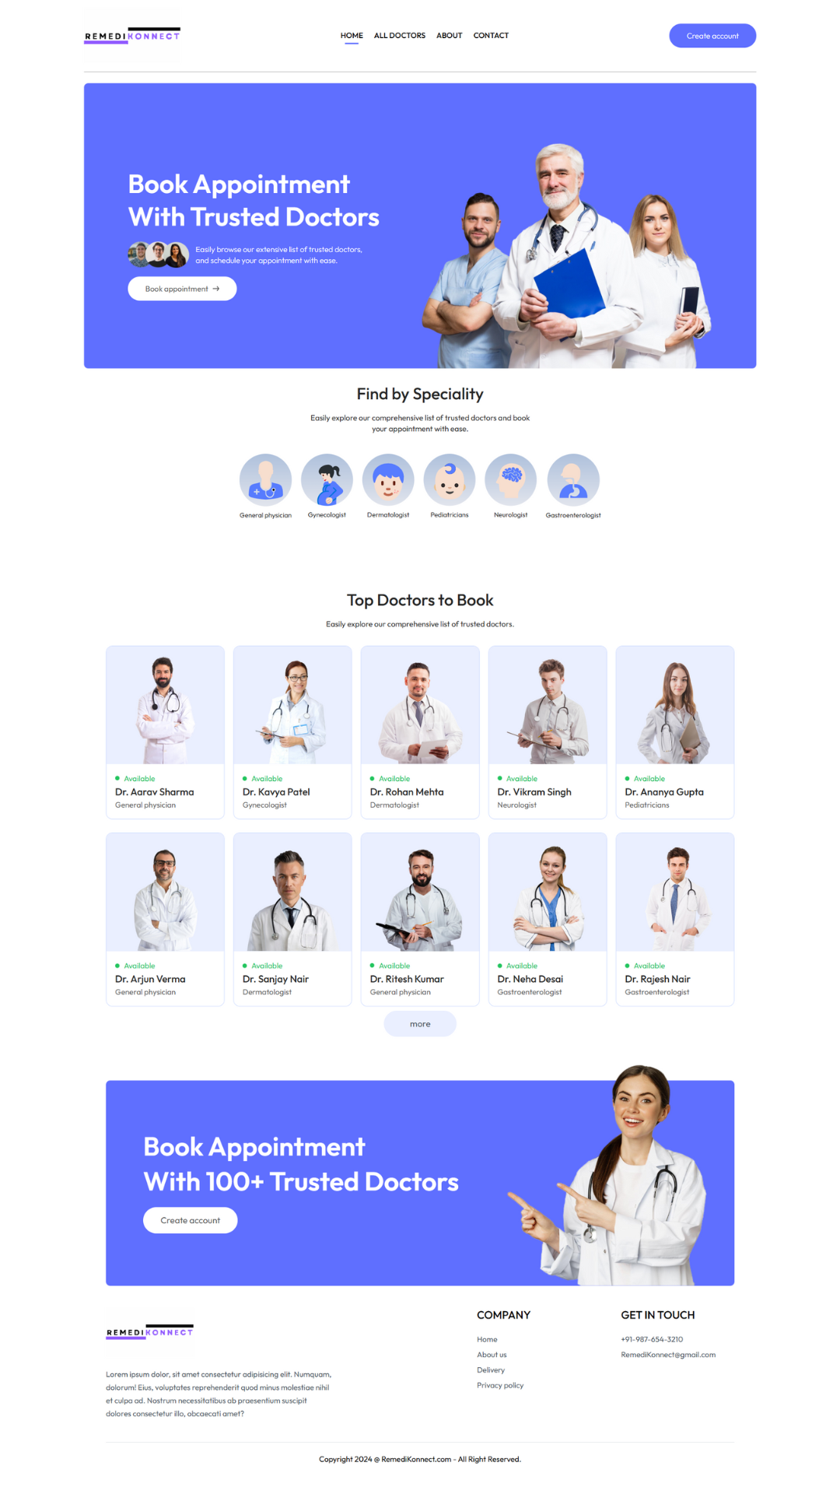

**Fig.no.1- Landing Page**

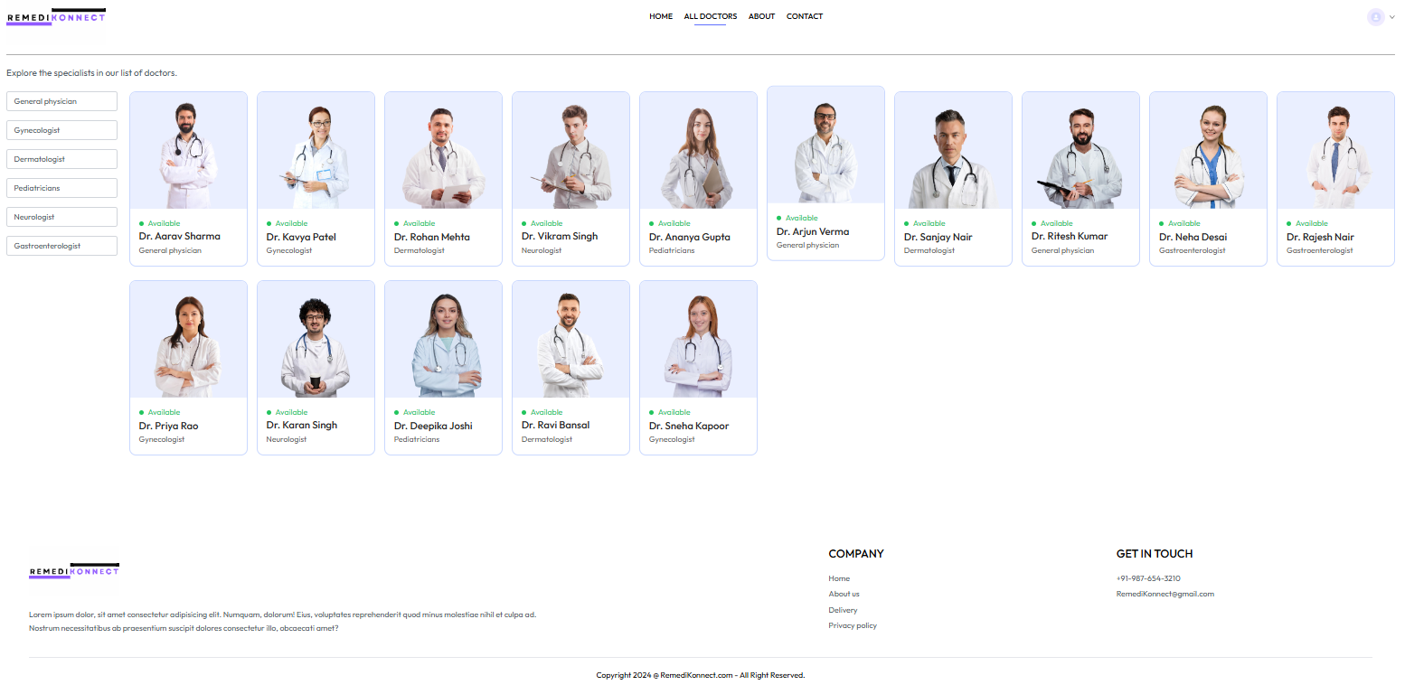

**Fig.no.2- All Doctors**

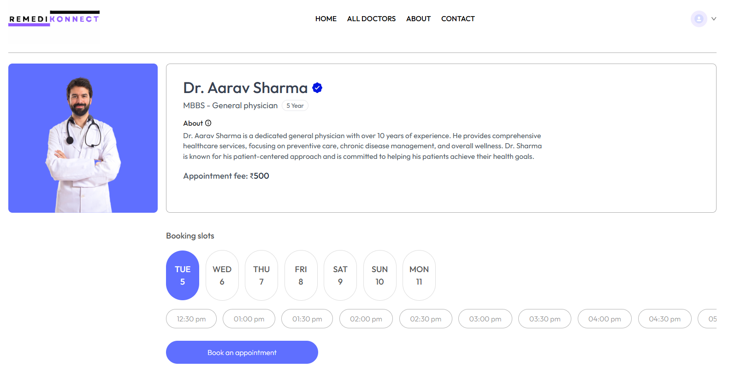

**Fig.no.3- Doctor’s Profile & Booking Slots**

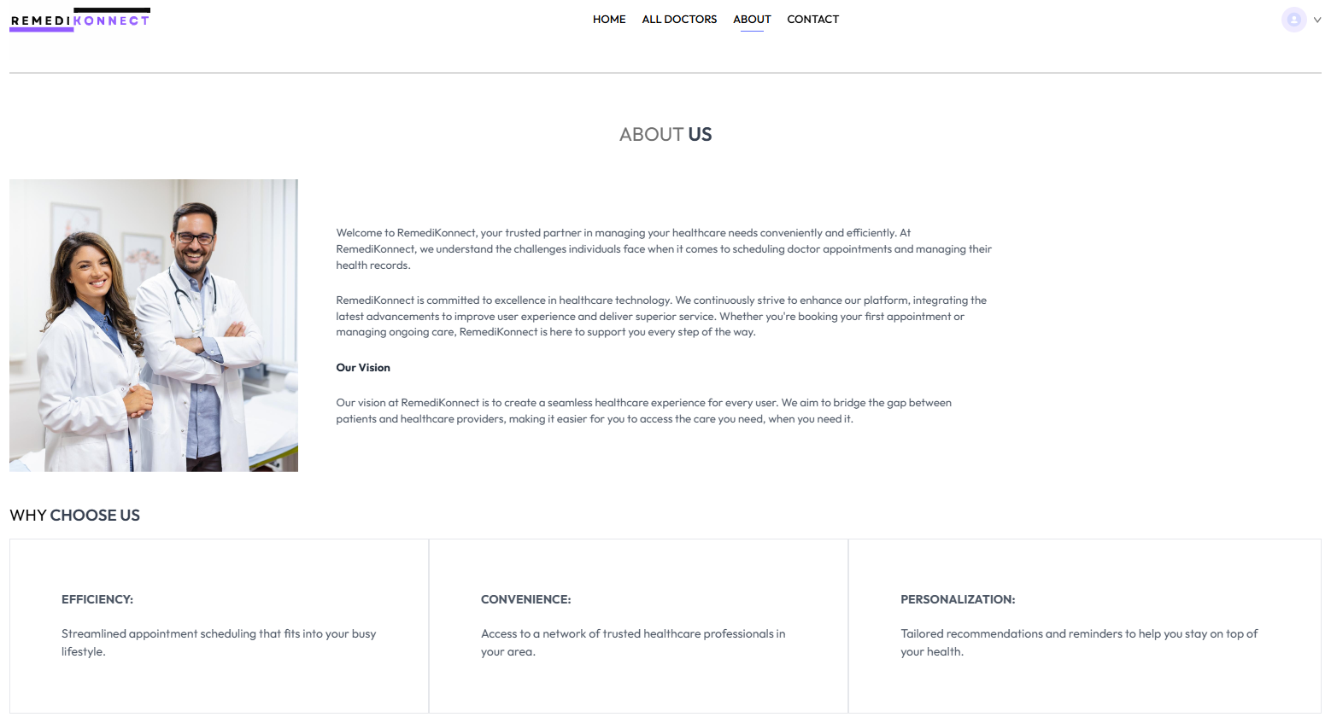

**Fig.no.4- About Us**

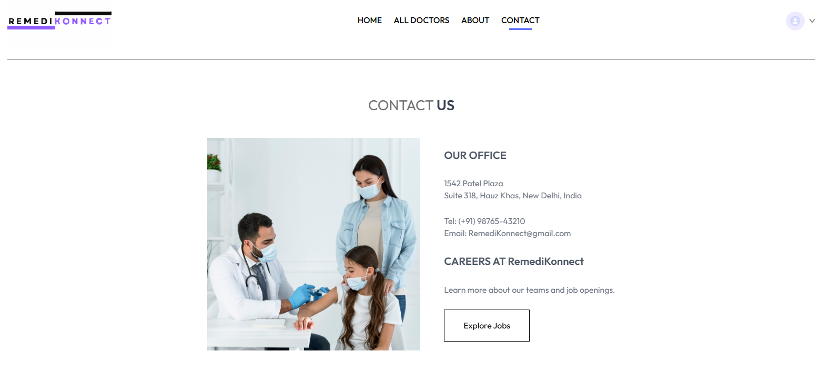

**Fig.no.5- Contact Us**

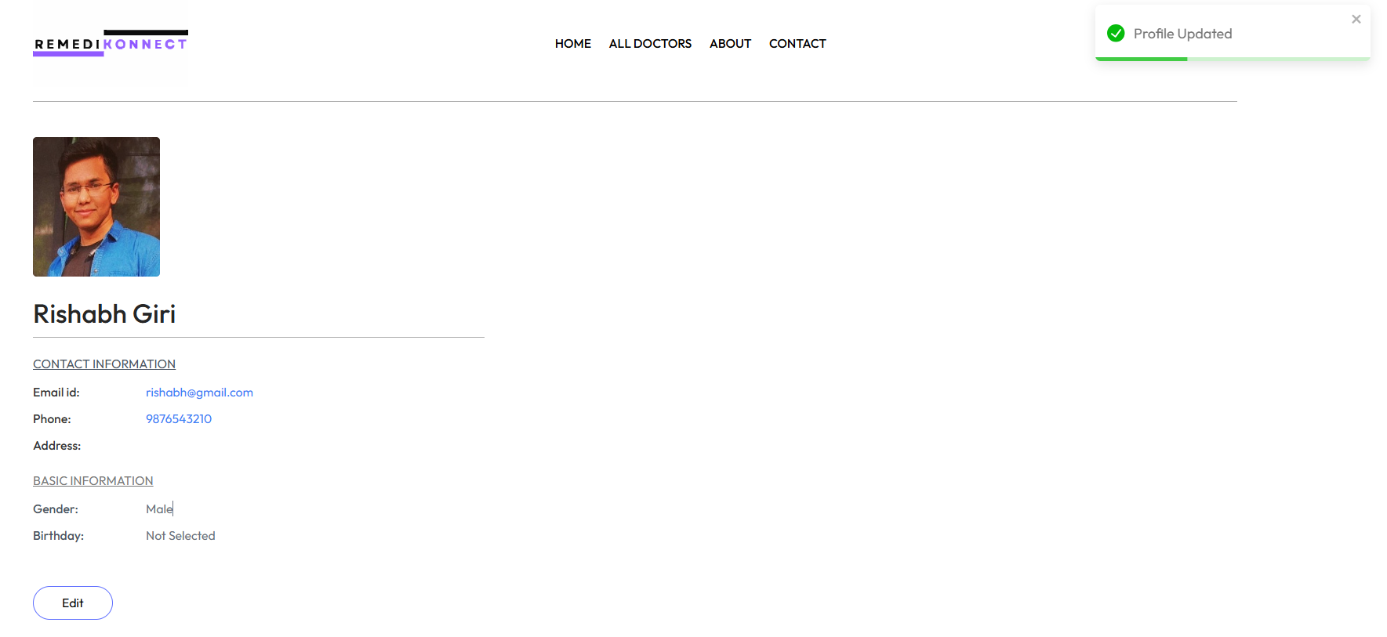

**Fig.no.6- User Profile**

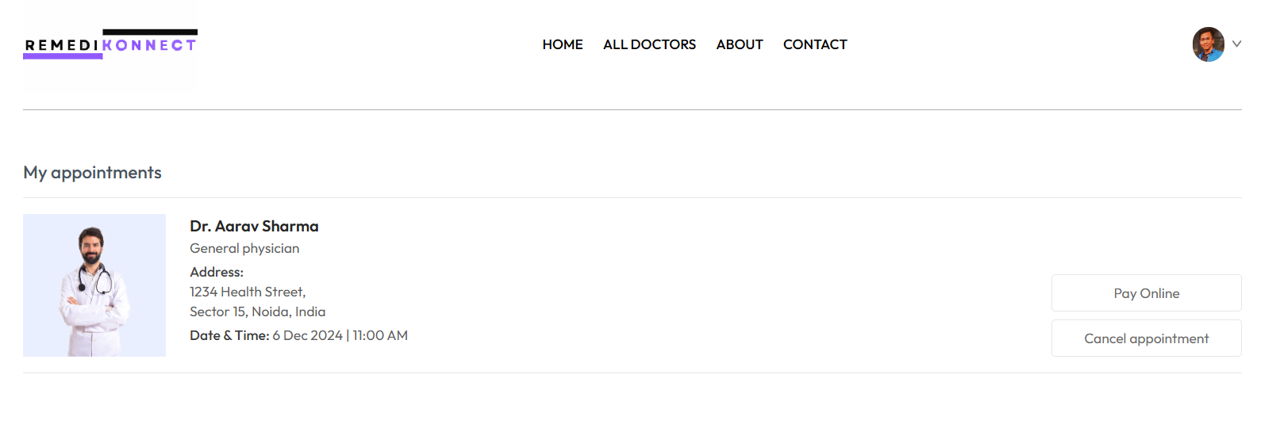

**Fig.no.7- My Appointment**

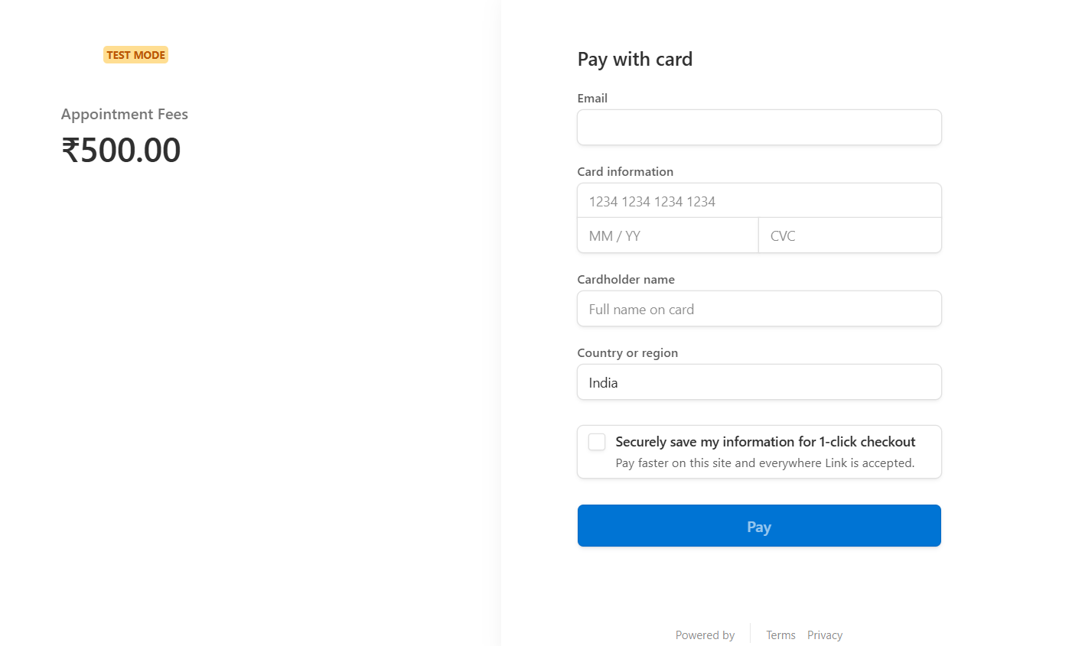

**Fig.no.8- Payment Gateway**

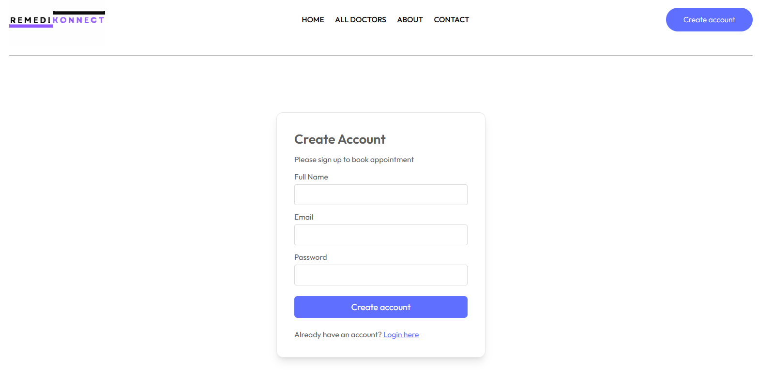

**Fig.no.9- Create Account**

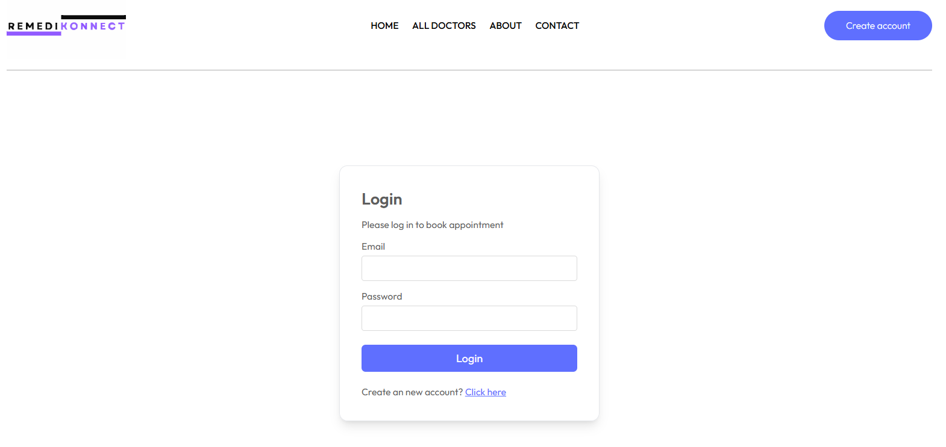

**Fig.no.10- Login**

1. **Admin Login**

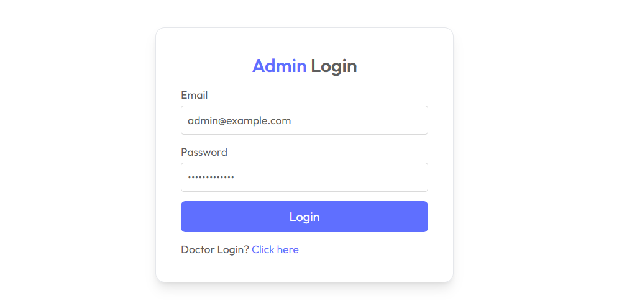

**Fig.no.11- Admin Login**

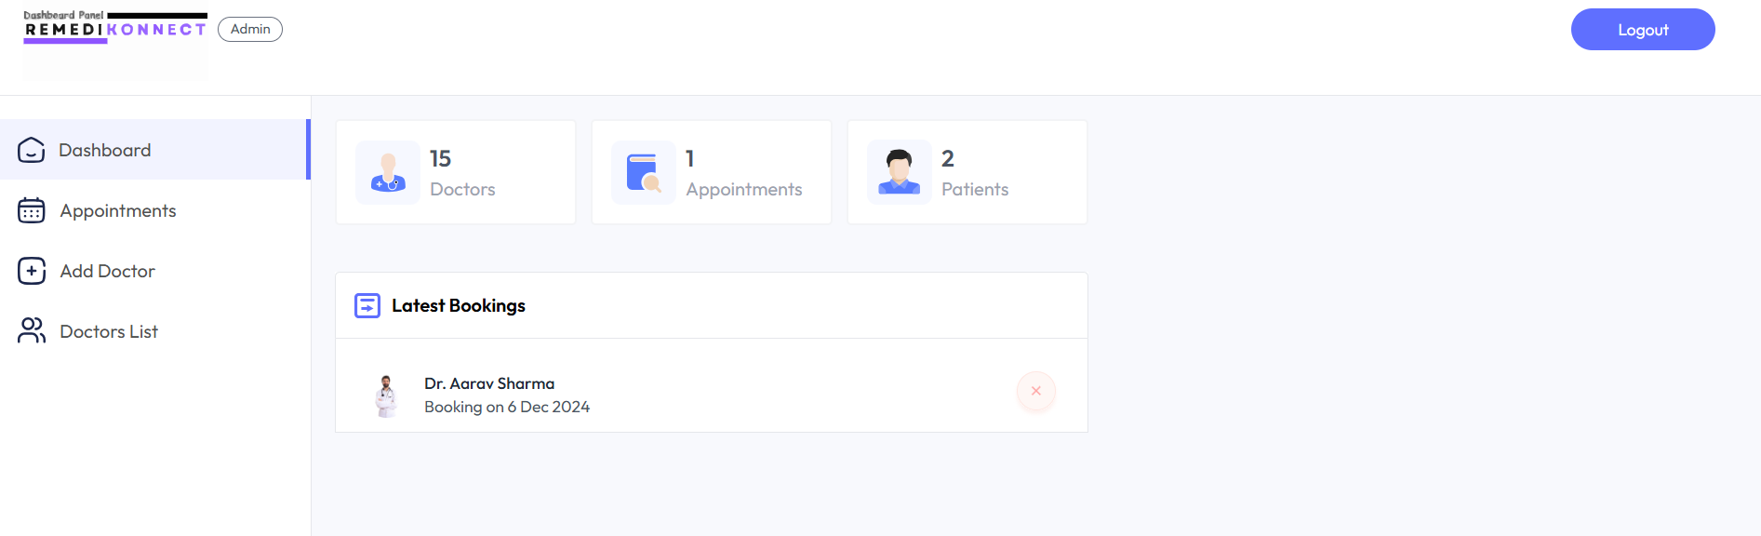

**Fig.no.12- Admin Dashboard**

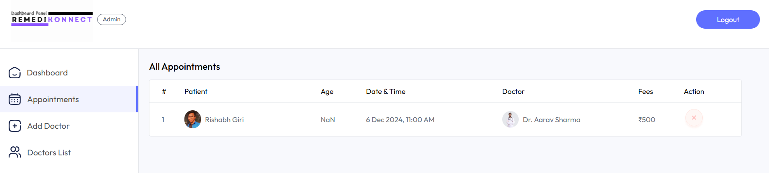

**Fig.no.13- Appointments**

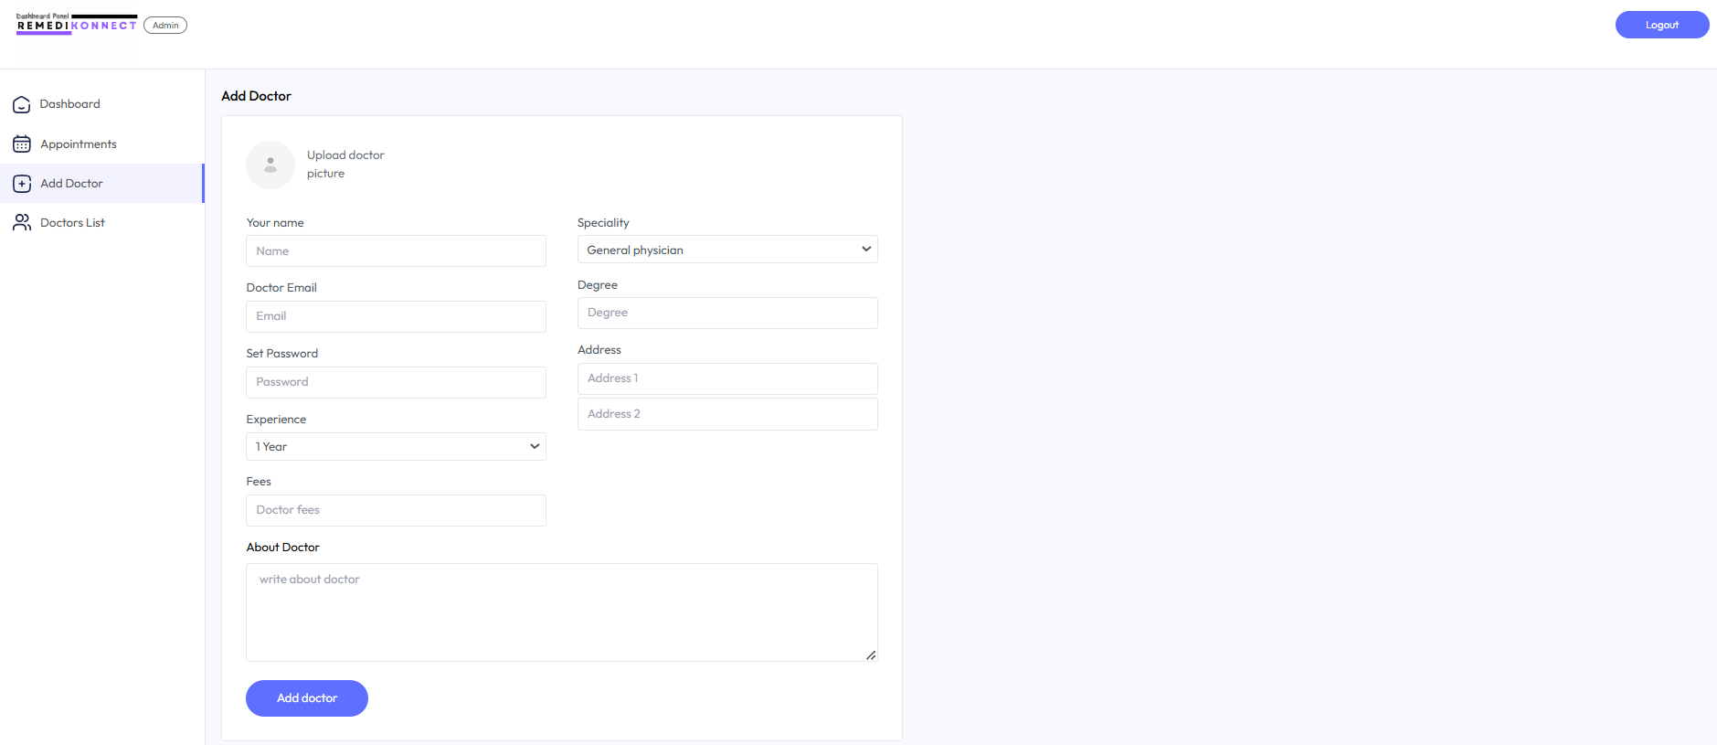

**Fig.no.14- Add Doctor**

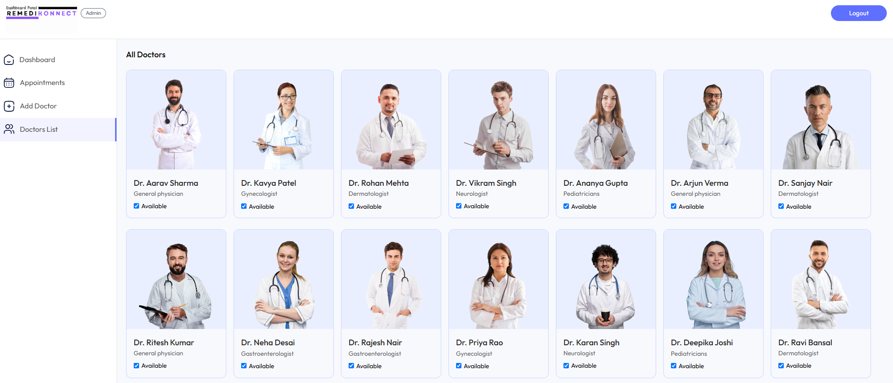

**Fig.no.15- Doctors List**

1. **Doctor Login**

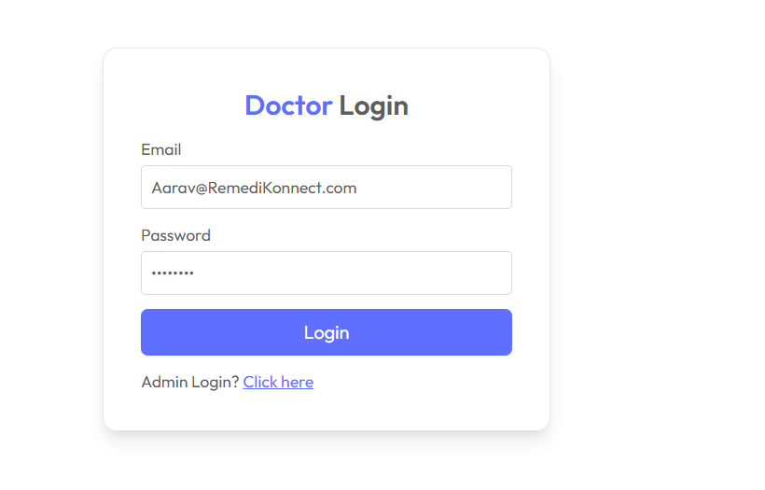

**Fig.no.16- Doctor Login**

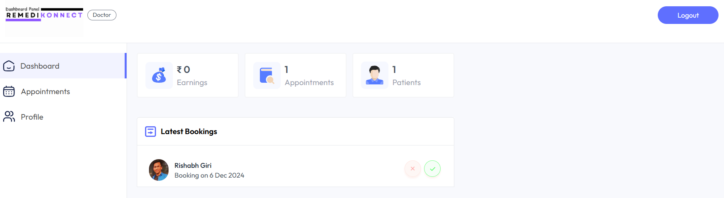

**Fig.no.17- Doctor Dashboard**

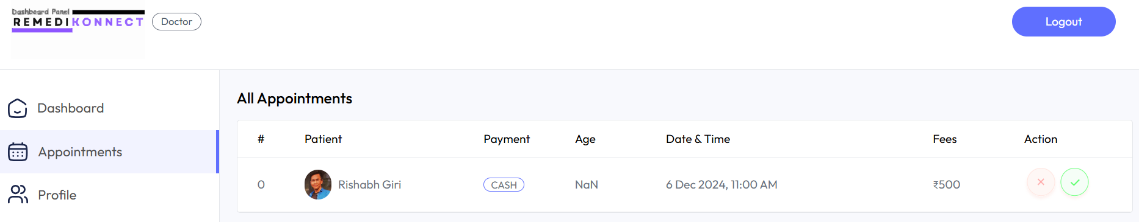

**Fig.no.18- Doctor Appointment**

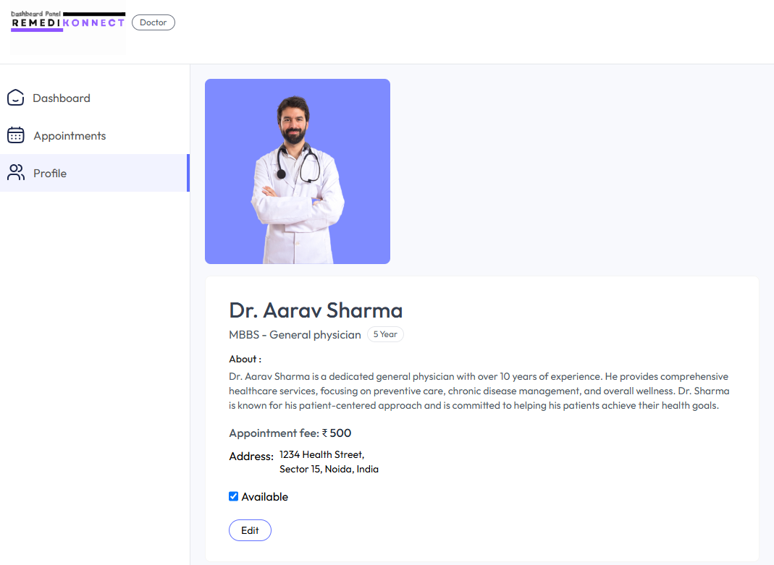

**Fig.no.19- Doctor’s Profile**

**Codes of the Web Application Interface**

* **Navbar.jsx**

|  |
| --- |
| import React, { useContext, useState } from 'react'  import { assets } from '../assets/assets'  import { NavLink, useNavigate } from 'react-router-dom'  import { AppContext } from '../context/AppContext'  const Navbar = () => {    const navigate = useNavigate()    const [showMenu, setShowMenu] = useState(false)    const { token, setToken, userData } = useContext(AppContext)    const logout = () => {      localStorage.removeItem('token')      setToken(false)      navigate('/login')    }    return (      <div className='flex items-center justify-between text-sm py-4 mb-5 border-b border-b-[#ADADAD]'>        <img onClick={() => navigate('/')} className='w-44 cursor-pointer' src={assets.logo} alt="" />        <ul className='md:flex items-start gap-5 font-medium hidden'>          <NavLink to='/' >            <li className='py-1'>HOME</li>            <hr className='border-none outline-none h-0.5 bg-primary w-3/5 m-auto hidden' />          </NavLink>          <NavLink to='/doctors' >            <li className='py-1'>ALL DOCTORS</li>            <hr className='border-none outline-none h-0.5 bg-primary w-3/5 m-auto hidden' />          </NavLink>          <NavLink to='/about' >            <li className='py-1'>ABOUT</li>            <hr className='border-none outline-none h-0.5 bg-primary w-3/5 m-auto hidden' />          </NavLink>          <NavLink to='/contact' >            <li className='py-1'>CONTACT</li>            <hr className='border-none outline-none h-0.5 bg-primary w-3/5 m-auto hidden' />          </NavLink>        </ul>        <div className='flex items-center gap-4 '>          {            token && userData              ? <div className='flex items-center gap-2 cursor-pointer group relative'>                <img className='w-8 rounded-full' src={userData.image} alt="" />                <img className='w-2.5' src={assets.dropdown_icon} alt="" />                <div className='absolute top-0 right-0 pt-14 text-base font-medium text-gray-600 z-20 hidden group-hover:block'>                  <div className='min-w-48 bg-gray-50 rounded flex flex-col gap-4 p-4'>                    <p onClick={() => navigate('/my-profile')} className='hover:text-black cursor-pointer'>My Profile</p>                    <p onClick={() => navigate('/my-appointments')} className='hover:text-black cursor-pointer'>My Appointments</p>                    <p onClick={logout} className='hover:text-black cursor-pointer'>Logout</p>                  </div>                </div>              </div>              : <button onClick={() => navigate('/login')} className='bg-primary text-white px-8 py-3 rounded-full font-light hidden md:block'>Create account</button>          }          <img onClick={() => setShowMenu(true)} className='w-6 md:hidden' src={assets.menu_icon} alt="" />          {/* ---- Mobile Menu ---- */}          <div className={`md:hidden ${showMenu ? 'fixed w-full' : 'h-0 w-0'} right-0 top-0 bottom-0 z-20 overflow-hidden bg-white transition-all`}>            <div className='flex items-center justify-between px-5 py-6'>              <img src={assets.logo} className='w-36' alt="" />              <img onClick={() => setShowMenu(false)} src={assets.cross_icon} className='w-7' alt="" />            </div>            <ul className='flex flex-col items-center gap-2 mt-5 px-5 text-lg font-medium'>              <NavLink onClick={() => setShowMenu(false)} to='/'><p className='px-4 py-2 rounded full inline-block'>HOME</p></NavLink>              <NavLink onClick={() => setShowMenu(false)} to='/doctors' ><p className='px-4 py-2 rounded full inline-block'>ALL DOCTORS</p></NavLink>              <NavLink onClick={() => setShowMenu(false)} to='/about' ><p className='px-4 py-2 rounded full inline-block'>ABOUT</p></NavLink>              <NavLink onClick={() => setShowMenu(false)} to='/contact' ><p className='px-4 py-2 rounded full inline-block'>CONTACT</p></NavLink>            </ul>          </div>        </div>      </div>    )  }  export default Navbar |

* **Header.jsx**

|  |
| --- |
| import React from 'react'  import { assets } from '../assets/assets'  const Header = () => {      return (          <div className='flex flex-col md:flex-row flex-wrap bg-primary rounded-lg px-6 md:px-10 lg:px-20 '>              {/* --------- Header Left --------- */}              <div className='md:w-1/2 flex flex-col items-start justify-center gap-4 py-10 m-auto md:py-[10vw] md:mb-[-30px]'>                  <p className='text-3xl md:text-4xl lg:text-5xl text-white font-semibold leading-tight md:leading-tight lg:leading-tight'>                      Book Appointment <br />  With Trusted Doctors                  </p>                  <div className='flex flex-col md:flex-row items-center gap-3 text-white text-sm font-light'>                      <img className='w-28' src={assets.group_profiles} alt="" />                      <p>Easily browse our extensive list of trusted doctors, <br className='hidden sm:block' /> and schedule your appointment with ease.</p>                  </div>                  <a href='#speciality' className='flex items-center gap-2 bg-white px-8 py-3 rounded-full text-[#595959] text-sm m-auto md:m-0 hover:scale-105 transition-all duration-300'>                      Book appointment <img className='w-3' src={assets.arrow_icon} alt="" />                  </a>              </div>              {/* --------- Header Right --------- */}              <div className='md:w-1/2 relative'>                  <img className='w-full md:absolute bottom-0 h-auto rounded-lg' src={assets.header_img} alt="" />              </div>          </div>      )  }  export default Header |

* **SpecialityMenu.jsx**

|  |
| --- |
| import React from 'react'  import { specialityData } from '../assets/assets'  import { Link } from 'react-router-dom'  const SpecialityMenu = () => {      return (          <div id='speciality' className='flex flex-col items-center gap-4 py-16 text-[#262626]'>              <h1 className='text-3xl font-medium'>Find by Speciality</h1>              <p className='sm:w-1/3 text-center text-sm'>Easily explore our comprehensive list of trusted doctors and book your appointment with ease.</p>              <div className='flex sm:justify-center gap-4 pt-5 w-full overflow-scroll '>                  {specialityData.map((item, index) => (                      <Link to={`/doctors/${item.speciality}`} onClick={() => scrollTo(0, 0)} className='flex flex-col items-center text-xs cursor-pointer flex-shrink-0 hover:translate-y-[-10px] transition-all duration-500' key={index}>                          <img className='w-16 sm:w-24 mb-2 ' src={item.image} alt="" />                          <p>{item.speciality}</p>                      </Link>                  ))}              </div>          </div>      )  }  export default SpecialityMenu |

* **TopDoctors.jsx**

|  |
| --- |
| import React, { useContext } from 'react'  import { useNavigate } from 'react-router-dom'  import { AppContext } from '../context/AppContext'  const TopDoctors = () => {      const navigate = useNavigate()      const { doctors } = useContext(AppContext)      return (          <div className='flex flex-col items-center gap-4 my-16 text-[#262626] md:mx-10'>              <h1 className='text-3xl font-medium'>Top Doctors to Book</h1>              <p className='sm:w-1/3 text-center text-sm'>Easily explore our comprehensive list of trusted doctors.</p>              <div className='w-full grid grid-cols-auto gap-4 pt-5 gap-y-6 px-3 sm:px-0'>                  {doctors.slice(0, 10).map((item, index) => (                      <div onClick={() => { navigate(`/appointment/${item._id}`); scrollTo(0, 0) }} className='border border-[#C9D8FF] rounded-xl overflow-hidden cursor-pointer hover:translate-y-[-10px] transition-all duration-500' key={index}>                          <img className='bg-[#EAEFFF]' src={item.image} alt="" />                          <div className='p-4'>                              <div className={`flex items-center gap-2 text-sm text-center ${item.available ? 'text-green-500' : "text-gray-500"}`}>                                  <p className={`w-2 h-2 rounded-full ${item.available ? 'bg-green-500' : "bg-gray-500"}`}></p><p>{item.available ? 'Available' : "Not Available"}</p>                              </div>                              <p className='text-[#262626] text-lg font-medium'>{item.name}</p>                              <p className='text-[#5C5C5C] text-sm'>{item.speciality}</p>                          </div>                      </div>                  ))}              </div>              <button onClick={() => { navigate('/doctors'); scrollTo(0, 0) }} className='bg-[#EAEFFF] text-gray-600 px-12 py-3 rounded-full mt-10'>more</button>          </div>      )  }  export default TopDoctors |

* **RelatedDoctors.jsx**

|  |
| --- |
| import React, { useContext, useEffect, useState } from 'react'  import { useNavigate } from 'react-router-dom'  import { AppContext } from '../context/AppContext'  const RelatedDoctors = ({ speciality, docId }) => {      const navigate = useNavigate()      const { doctors } = useContext(AppContext)      const [relDoc, setRelDoc] = useState([])      useEffect(() => {          if (doctors.length > 0 && speciality) {              const doctorsData = doctors.filter((doc) => doc.speciality === speciality && doc._id !== docId)              setRelDoc(doctorsData)          }      }, [doctors, speciality, docId])      return (          <div className='flex flex-col items-center gap-4 my-16 text-[#262626]'>              <h1 className='text-3xl font-medium'>Related Doctors</h1>              <p className='sm:w-1/3 text-center text-sm'>Simply browse through our extensive list of trusted doctors.</p>              <div className='w-full grid grid-cols-auto gap-4 pt-5 gap-y-6 px-3 sm:px-0'>                  {relDoc.map((item, index) => (                      <div onClick={() => { navigate(`/appointment/${item._id}`); scrollTo(0, 0) }} className='border border-[#C9D8FF] rounded-xl overflow-hidden cursor-pointer hover:translate-y-[-10px] transition-all duration-500' key={index}>                          <img className='bg-[#EAEFFF]' src={item.image} alt="" />                          <div className='p-4'>                              <div className={`flex items-center gap-2 text-sm text-center ${item.available ? 'text-green-500' : "text-gray-500"}`}>                                  <p className={`w-2 h-2 rounded-full ${item.available ? 'bg-green-500' : "bg-gray-500"}`}></p><p>{item.available ? 'Available' : "Not Available"}</p>                              </div>                              <p className='text-[#262626] text-lg font-medium'>{item.name}</p>                              <p className='text-[#5C5C5C] text-sm'>{item.speciality}</p>                          </div>                      </div>                  ))}              </div>              {/* <button className='bg-[#EAEFFF] text-gray-600 px-12 py-3 rounded-full mt-10'>more</button> */}          </div>      )  }  export default RelatedDoctors |

* **Banner.jsx**

|  |
| --- |
| import React from 'react'  import { assets } from '../assets/assets'  import { useNavigate } from 'react-router-dom'  const Banner = () => {      const navigate = useNavigate()      return (          <div className='flex bg-primary rounded-lg  px-6 sm:px-10 md:px-14 lg:px-12 my-20 md:mx-10'>              {/* ------- Left Side ------- */}              <div className='flex-1 py-8 sm:py-10 md:py-16 lg:py-24 lg:pl-5'>                  <div className='text-xl sm:text-2xl md:text-3xl lg:text-5xl font-semibold text-white'>                      <p>Book Appointment</p>                      <p className='mt-4'>With 100+ Trusted Doctors</p>                  </div>                  <button onClick={() => { navigate('/login'); scrollTo(0, 0) }} className='bg-white text-sm sm:text-base text-[#595959] px-8 py-3 rounded-full mt-6 hover:scale-105 transition-all '>Create account</button>              </div>              {/* ------- Right Side ------- */}              <div className='hidden md:block md:w-1/2 lg:w-[370px] relative'>                  <img className='w-full absolute bottom-0 right-0 max-w-md' src={assets.appointment_img} alt="" />              </div>          </div>      )  }  export default Banner |

* **Footer.jsx**

|  |
| --- |
| import React from 'react'  import { assets } from '../assets/assets'  const Footer = () => {    return (      <div className='md:mx-10'>        <div className='flex flex-col sm:grid grid-cols-[3fr_1fr_1fr] gap-14 my-10  mt-40 text-sm'>          <div>            <img className='mb-5 w-40' src={assets.logo} alt="" />            <p className='w-full md:w-2/3 text-gray-600 leading-6'>Lorem ipsum dolor, sit amet consectetur adipisicing elit. Numquam, dolorum! Eius, voluptates reprehenderit quod minus molestiae nihil et culpa ad. Nostrum necessitatibus ab praesentium suscipit dolores consectetur illo, obcaecati amet?</p>          </div>          <div>            <p className='text-xl font-medium mb-5'>COMPANY</p>            <ul className='flex flex-col gap-2 text-gray-600'>              <li>Home</li>              <li>About us</li>              <li>Delivery</li>              <li>Privacy policy</li>            </ul>          </div>          <div>            <p className='text-xl font-medium mb-5'>GET IN TOUCH</p>            <ul className='flex flex-col gap-2 text-gray-600'>              <li>+91-987-654-3210</li>              <li>RemediKonnect@gmail.com</li>            </ul>          </div>        </div>        <div>          <hr />          <p className='py-5 text-sm text-center'>Copyright 2024 @ RemediKonnect.com - All Right Reserved.</p>        </div>      </div>    )  }  export default Footer |

* **Home.jsx**

|  |
| --- |
| import React from 'react'  import Header from '../components/Header'  import SpecialityMenu from '../components/SpecialityMenu'  import TopDoctors from '../components/TopDoctors'  import Banner from '../components/Banner'  const Home = () => {    return (      <div>        <Header />        <SpecialityMenu />        <TopDoctors />        <Banner />      </div>    )  }  export default Home |

* **Doctors.jsx**

|  |
| --- |
| import React, { useContext, useEffect, useState } from 'react'  import { AppContext } from '../context/AppContext'  import { useNavigate, useParams } from 'react-router-dom'  const Doctors = () => {    const { speciality } = useParams()    const [filterDoc, setFilterDoc] = useState([])    const [showFilter, setShowFilter] = useState(false)    const navigate = useNavigate();    const { doctors } = useContext(AppContext)    const applyFilter = () => {      if (speciality) {        setFilterDoc(doctors.filter(doc => doc.speciality === speciality))      } else {        setFilterDoc(doctors)      }    }    useEffect(() => {      applyFilter()    }, [doctors, speciality])    return (      <div>        <p className='text-gray-600'>Explore the specialists in our list of doctors.</p>        <div className='flex flex-col sm:flex-row items-start gap-5 mt-5'>          <button onClick={() => setShowFilter(!showFilter)} className={`py-1 px-3 border rounded text-sm  transition-all sm:hidden ${showFilter ? 'bg-primary text-white' : ''}`}>Filters</button>          <div className={`flex-col gap-4 text-sm text-gray-600 ${showFilter ? 'flex' : 'hidden sm:flex'}`}>            <p onClick={() => speciality === 'General physician' ? navigate('/doctors') : navigate('/doctors/General physician')} className={`w-[94vw] sm:w-auto pl-3 py-1.5 pr-16 border border-gray-300 rounded transition-all cursor-pointer ${speciality === 'General physician' ? 'bg-[#E2E5FF] text-black ' : ''}`}>General physician</p>            <p onClick={() => speciality === 'Gynecologist' ? navigate('/doctors') : navigate('/doctors/Gynecologist')} className={`w-[94vw] sm:w-auto pl-3 py-1.5 pr-16 border border-gray-300 rounded transition-all cursor-pointer ${speciality === 'Gynecologist' ? 'bg-[#E2E5FF] text-black ' : ''}`}>Gynecologist</p>            <p onClick={() => speciality === 'Dermatologist' ? navigate('/doctors') : navigate('/doctors/Dermatologist')} className={`w-[94vw] sm:w-auto pl-3 py-1.5 pr-16 border border-gray-300 rounded transition-all cursor-pointer ${speciality === 'Dermatologist' ? 'bg-[#E2E5FF] text-black ' : ''}`}>Dermatologist</p>            <p onClick={() => speciality === 'Pediatricians' ? navigate('/doctors') : navigate('/doctors/Pediatricians')} className={`w-[94vw] sm:w-auto pl-3 py-1.5 pr-16 border border-gray-300 rounded transition-all cursor-pointer ${speciality === 'Pediatricians' ? 'bg-[#E2E5FF] text-black ' : ''}`}>Pediatricians</p>            <p onClick={() => speciality === 'Neurologist' ? navigate('/doctors') : navigate('/doctors/Neurologist')} className={`w-[94vw] sm:w-auto pl-3 py-1.5 pr-16 border border-gray-300 rounded transition-all cursor-pointer ${speciality === 'Neurologist' ? 'bg-[#E2E5FF] text-black ' : ''}`}>Neurologist</p>            <p onClick={() => speciality === 'Gastroenterologist' ? navigate('/doctors') : navigate('/doctors/Gastroenterologist')} className={`w-[94vw] sm:w-auto pl-3 py-1.5 pr-16 border border-gray-300 rounded transition-all cursor-pointer ${speciality === 'Gastroenterologist' ? 'bg-[#E2E5FF] text-black ' : ''}`}>Gastroenterologist</p>          </div>          <div className='w-full grid grid-cols-auto gap-4 gap-y-6'>            {filterDoc.map((item, index) => (              <div onClick={() => { navigate(`/appointment/${item._id}`); scrollTo(0, 0) }} className='border border-[#C9D8FF] rounded-xl overflow-hidden cursor-pointer hover:translate-y-[-10px] transition-all duration-500' key={index}>                <img className='bg-[#EAEFFF]' src={item.image} alt="" />                <div className='p-4'>                  <div className={`flex items-center gap-2 text-sm text-center ${item.available ? 'text-green-500' : "text-gray-500"}`}>                    <p className={`w-2 h-2 rounded-full ${item.available ? 'bg-green-500' : "bg-gray-500"}`}></p><p>{item.available ? 'Available' : "Not Available"}</p>                  </div>                  <p className='text-[#262626] text-lg font-medium'>{item.name}</p>                  <p className='text-[#5C5C5C] text-sm'>{item.speciality}</p>                </div>              </div>            ))}          </div>        </div>      </div>    )  }  export default Doctors |

* **About.jsx**

|  |
| --- |
| import React from 'react'  import { assets } from '../assets/assets'  const About = () => {    return (      <div>        <div className='text-center text-2xl pt-10 text-[#707070]'>          <p>ABOUT <span className='text-gray-700 font-semibold'>US</span></p>        </div>        <div className='my-10 flex flex-col md:flex-row gap-12'>          <img className='w-full md:max-w-[360px]' src={assets.about_image} alt="" />          <div className='flex flex-col justify-center gap-6 md:w-2/4 text-sm text-gray-600'>            <p>Welcome to RemediKonnect, your trusted partner in managing your healthcare needs conveniently and efficiently. At RemediKonnect, we understand the challenges individuals face when it comes to scheduling doctor appointments and managing their health records.</p>            <p>RemediKonnect is committed to excellence in healthcare technology. We continuously strive to enhance our platform, integrating the latest advancements to improve user experience and deliver superior service. Whether you're booking your first appointment or managing ongoing care, RemediKonnect is here to support you every step of the way.</p>            <b className='text-gray-800'>Our Vision</b>            <p>Our vision at RemediKonnect is to create a seamless healthcare experience for every user. We aim to bridge the gap between patients and healthcare providers, making it easier for you to access the care you need, when you need it.</p>          </div>        </div>        <div className='text-xl my-4'>          <p>WHY  <span className='text-gray-700 font-semibold'>CHOOSE US</span></p>        </div>        <div className='flex flex-col md:flex-row mb-20'>          <div className='border px-10 md:px-16 py-8 sm:py-16 flex flex-col gap-5 text-[15px] hover:bg-primary hover:text-white transition-all duration-300 text-gray-600 cursor-pointer'>            <b>EFFICIENCY:</b>            <p>Streamlined appointment scheduling that fits into your busy lifestyle.</p>          </div>          <div className='border px-10 md:px-16 py-8 sm:py-16 flex flex-col gap-5 text-[15px] hover:bg-primary hover:text-white transition-all duration-300 text-gray-600 cursor-pointer'>            <b>CONVENIENCE: </b>            <p>Access to a network of trusted healthcare professionals in your area.</p>          </div>          <div className='border px-10 md:px-16 py-8 sm:py-16 flex flex-col gap-5 text-[15px] hover:bg-primary hover:text-white transition-all duration-300 text-gray-600 cursor-pointer'>            <b>PERSONALIZATION:</b>            <p >Tailored recommendations and reminders to help you stay on top of your health.</p>          </div>        </div>      </div>    )  }  export default About |

* **Contact.jsx**

|  |
| --- |
| import React from 'react'  import { assets } from '../assets/assets'  const Contact = () => {    return (      <div>        <div className='text-center text-2xl pt-10 text-[#707070]'>          <p>CONTACT <span className='text-gray-700 font-semibold'>US</span></p>        </div>        <div className='my-10 flex flex-col justify-center md:flex-row gap-10 mb-28 text-sm'>          <img className='w-full md:max-w-[360px]' src={assets.contact_image} alt="" />          <div className='flex flex-col justify-center items-start gap-6'>            <p className=' font-semibold text-lg text-gray-600'>OUR OFFICE</p>            <p className=' text-gray-500'>1542 Patel Plaza <br /> Suite 318, Hauz Khas, New Delhi, India</p>            <p className=' text-gray-500'>Tel: (+91) 98765-43210 <br /> Email: RemediKonnect@gmail.com</p>            <p className=' font-semibold text-lg text-gray-600'>CAREERS AT RemediKonnect</p>            <p className=' text-gray-500'>Learn more about our teams and job openings.</p>            <button className='border border-black px-8 py-4 text-sm hover:bg-black hover:text-white transition-all duration-500'>Explore Jobs</button>          </div>        </div>      </div>    )  }  export default Contact |

* **Appointment.jsx**

|  |
| --- |
| import React, { useContext, useEffect, useState } from 'react'  import { useNavigate, useParams } from 'react-router-dom'  import { AppContext } from '../context/AppContext'  import { assets } from '../assets/assets'  import RelatedDoctors from '../components/RelatedDoctors'  import axios from 'axios'  import { toast } from 'react-toastify'  const Appointment = () => {      const { docId } = useParams()      const { doctors, currencySymbol, backendUrl, token, getDoctosData } = useContext(AppContext)      const daysOfWeek = ['SUN', 'MON', 'TUE', 'WED', 'THU', 'FRI', 'SAT']      const [docInfo, setDocInfo] = useState(false)      const [docSlots, setDocSlots] = useState([])      const [slotIndex, setSlotIndex] = useState(0)      const [slotTime, setSlotTime] = useState('')      const navigate = useNavigate()      const fetchDocInfo = async () => {          const docInfo = doctors.find((doc) => doc._id === docId)          setDocInfo(docInfo)      }      const getAvailableSolts = async () => {          setDocSlots([])          // getting current date          let today = new Date()          for (let i = 0; i < 7; i++) {              // getting date with index              let currentDate = new Date(today)              currentDate.setDate(today.getDate() + i)              // setting end time of the date with index              let endTime = new Date()              endTime.setDate(today.getDate() + i)              endTime.setHours(21, 0, 0, 0)              // setting hours              if (today.getDate() === currentDate.getDate()) {                  currentDate.setHours(currentDate.getHours() > 10 ? currentDate.getHours() + 1 : 10)                  currentDate.setMinutes(currentDate.getMinutes() > 30 ? 30 : 0)              } else {                  currentDate.setHours(10)                  currentDate.setMinutes(0)              }              let timeSlots = [];              while (currentDate < endTime) {                  let formattedTime = currentDate.toLocaleTimeString([], { hour: '2-digit', minute: '2-digit' });                  let day = currentDate.getDate()                  let month = currentDate.getMonth() + 1                  let year = currentDate.getFullYear()                  const slotDate = day + "_" + month + "_" + year                  const slotTime = formattedTime                  const isSlotAvailable = docInfo.slots_booked[slotDate] && docInfo.slots_booked[slotDate].includes(slotTime) ? false : true                  if (isSlotAvailable) {                      // Add slot to array                      timeSlots.push({                          datetime: new Date(currentDate),                          time: formattedTime                      })                  }                  // Increment current time by 30 minutes                  currentDate.setMinutes(currentDate.getMinutes() + 30);              }              setDocSlots(prev => ([...prev, timeSlots]))          }      }      const bookAppointment = async () => {          if (!token) {              toast.warning('Login to book appointment')              return navigate('/login')          }          const date = docSlots[slotIndex][0].datetime          let day = date.getDate()          let month = date.getMonth() + 1          let year = date.getFullYear()          const slotDate = day + "_" + month + "_" + year          try {              const { data } = await axios.post(backendUrl + '/api/user/book-appointment', { docId, slotDate, slotTime }, { headers: { token } })              if (data.success) {                  toast.success(data.message)                  getDoctosData()                  navigate('/my-appointments')              } else {                  toast.error(data.message)              }          } catch (error) {              console.log(error)              toast.error(error.message)          }      }      useEffect(() => {          if (doctors.length > 0) {              fetchDocInfo()          }      }, [doctors, docId])      useEffect(() => {          if (docInfo) {              getAvailableSolts()          }      }, [docInfo])      return docInfo ? (          <div>              {/* ---------- Doctor Details ----------- */}              <div className='flex flex-col sm:flex-row gap-4'>                  <div>                      <img className='bg-primary w-full sm:max-w-72 rounded-lg' src={docInfo.image} alt="" />                  </div>                  <div className='flex-1 border border-[#ADADAD] rounded-lg p-8 py-7 bg-white mx-2 sm:mx-0 mt-[-80px] sm:mt-0'>                      {/* ----- Doc Info : name, degree, experience ----- */}                      <p className='flex items-center gap-2 text-3xl font-medium text-gray-700'>{docInfo.name} <img className='w-5' src={assets.verified_icon} alt="" /></p>                      <div className='flex items-center gap-2 mt-1 text-gray-600'>                          <p>{docInfo.degree} - {docInfo.speciality}</p>                          <button className='py-0.5 px-2 border text-xs rounded-full'>{docInfo.experience}</button>                      </div>                      {/* ----- Doc About ----- */}                      <div>                          <p className='flex items-center gap-1 text-sm font-medium text-[#262626] mt-3'>About <img className='w-3' src={assets.info_icon} alt="" /></p>                          <p className='text-sm text-gray-600 max-w-[700px] mt-1'>{docInfo.about}</p>                      </div>                      <p className='text-gray-600 font-medium mt-4'>Appointment fee: <span className='text-gray-800'>{currencySymbol}{docInfo.fees}</span> </p>                  </div>              </div>              {/* Booking slots */}              <div className='sm:ml-72 sm:pl-4 mt-8 font-medium text-[#565656]'>                  <p >Booking slots</p>                  <div className='flex gap-3 items-center w-full overflow-x-scroll mt-4'>                      {docSlots.length && docSlots.map((item, index) => (                          <div onClick={() => setSlotIndex(index)} key={index} className={`text-center py-6 min-w-16 rounded-full cursor-pointer ${slotIndex === index ? 'bg-primary text-white' : 'border border-[#DDDDDD]'}`}>                              <p>{item[0] && daysOfWeek[item[0].datetime.getDay()]}</p>                              <p>{item[0] && item[0].datetime.getDate()}</p>                          </div>                      ))}                  </div>                  <div className='flex items-center gap-3 w-full overflow-x-scroll mt-4'>                      {docSlots.length && docSlots[slotIndex].map((item, index) => (                          <p onClick={() => setSlotTime(item.time)} key={index} className={`text-sm font-light  flex-shrink-0 px-5 py-2 rounded-full cursor-pointer ${item.time === slotTime ? 'bg-primary text-white' : 'text-[#949494] border border-[#B4B4B4]'}`}>{item.time.toLowerCase()}</p>                      ))}                  </div>                  <button onClick={bookAppointment} className='bg-primary text-white text-sm font-light px-20 py-3 rounded-full my-6'>Book an appointment</button>              </div>              {/* Listing Releated Doctors */}              <RelatedDoctors speciality={docInfo.speciality} docId={docId} />          </div>      ) : null  }  export default Appointment |

* **MyAppointments.jsx**

|  |
| --- |
| import React, { useContext, useEffect, useState } from 'react'  import { useNavigate } from 'react-router-dom'  import { AppContext } from '../context/AppContext'  import axios from 'axios'  import { toast } from 'react-toastify'  import { assets } from '../assets/assets'  const MyAppointments = () => {      const { backendUrl, token } = useContext(AppContext)      const navigate = useNavigate()      const [appointments, setAppointments] = useState([])      const [payment, setPayment] = useState('')      const months = ["Jan", "Feb", "Mar", "Apr", "May", "Jun", "Jul", "Aug", "Sep", "Oct", "Nov", "Dec"];      // Function to format the date eg. ( 20_01_2000 => 20 Jan 2000 )      const slotDateFormat = (slotDate) => {          const dateArray = slotDate.split('_')          return dateArray[0] + " " + months[Number(dateArray[1])] + " " + dateArray[2]      }      // Getting User Appointments Data Using API      const getUserAppointments = async () => {          try {              const { data } = await axios.get(backendUrl + '/api/user/appointments', { headers: { token } })              setAppointments(data.appointments.reverse())          } catch (error) {              console.log(error)              toast.error(error.message)          }      }      // Function to cancel appointment Using API      const cancelAppointment = async (appointmentId) => {          try {              const { data } = await axios.post(backendUrl + '/api/user/cancel-appointment', { appointmentId }, { headers: { token } })              if (data.success) {                  toast.success(data.message)                  getUserAppointments()              } else {                  toast.error(data.message)              }          } catch (error) {              console.log(error)              toast.error(error.message)          }      }      const initPay = (order) => {          const options = {              key: import.meta.env.VITE_RAZORPAY_KEY_ID,              amount: order.amount,              currency: order.currency,              name: 'Appointment Payment',              description: "Appointment Payment",              order_id: order.id,              receipt: order.receipt,              handler: async (response) => {                  console.log(response)                  try {                      const { data } = await axios.post(backendUrl + "/api/user/verifyRazorpay", response, { headers: { token } });                      if (data.success) {                          navigate('/my-appointments')                          getUserAppointments()                      }                  } catch (error) {                      console.log(error)                      toast.error(error.message)                  }              }          };          const rzp = new window.Razorpay(options);          rzp.open();      };      // Function to make payment using razorpay      const appointmentRazorpay = async (appointmentId) => {          try {              const { data } = await axios.post(backendUrl + '/api/user/payment-razorpay', { appointmentId }, { headers: { token } })              if (data.success) {                  initPay(data.order)              }else{                  toast.error(data.message)              }          } catch (error) {              console.log(error)              toast.error(error.message)          }      }      // Function to make payment using stripe      const appointmentStripe = async (appointmentId) => {          try {              const { data } = await axios.post(backendUrl + '/api/user/payment-stripe', { appointmentId }, { headers: { token } })              if (data.success) {                  const { session_url } = data                  window.location.replace(session_url)              }else{                  toast.error(data.message)              }          } catch (error) {              console.log(error)              toast.error(error.message)          }      }        useEffect(() => {          if (token) {              getUserAppointments()          }      }, [token])      return (          <div>              <p className='pb-3 mt-12 text-lg font-medium text-gray-600 border-b'>My appointments</p>              <div className=''>                  {appointments.map((item, index) => (                      <div key={index} className='grid grid-cols-[1fr_2fr] gap-4 sm:flex sm:gap-6 py-4 border-b'>                          <div>                              <img className='w-36 bg-[#EAEFFF]' src={item.docData.image} alt="" />                          </div>                          <div className='flex-1 text-sm text-[#5E5E5E]'>                              <p className='text-[#262626] text-base font-semibold'>{item.docData.name}</p>                              <p>{item.docData.speciality}</p>                              <p className='text-[#464646] font-medium mt-1'>Address:</p>                              <p className=''>{item.docData.address.line1}</p>                              <p className=''>{item.docData.address.line2}</p>                              <p className=' mt-1'><span className='text-sm text-[#3C3C3C] font-medium'>Date & Time:</span> {slotDateFormat(item.slotDate)} |  {item.slotTime}</p>                          </div>                          <div></div>                          <div className='flex flex-col gap-2 justify-end text-sm text-center'>                              {!item.cancelled && !item.payment && !item.isCompleted && payment !== item._id && <button onClick={() => setPayment(item._id)} className='text-[#696969] sm:min-w-48 py-2 border rounded hover:bg-primary hover:text-white transition-all duration-300'>Pay Online</button>}                              {!item.cancelled && !item.payment && !item.isCompleted && payment === item._id && <button onClick={() => appointmentStripe(item._id)} className='text-[#696969] sm:min-w-48 py-2 border rounded hover:bg-gray-100 hover:text-white transition-all duration-300 flex items-center justify-center'><img className='max-w-20 max-h-5' src={assets.stripe_logo} alt="" /></button>}                              {!item.cancelled && !item.payment && !item.isCompleted && payment === item._id && <button onClick={() => appointmentRazorpay(item._id)} className='text-[#696969] sm:min-w-48 py-2 border rounded hover:bg-gray-100 hover:text-white transition-all duration-300 flex items-center justify-center'><img className='max-w-20 max-h-5' src={assets.razorpay_logo} alt="" /></button>}                              {!item.cancelled && item.payment && !item.isCompleted && <button className='sm:min-w-48 py-2 border rounded text-[#696969]  bg-[#EAEFFF]'>Paid</button>}                              {item.isCompleted && <button className='sm:min-w-48 py-2 border border-green-500 rounded text-green-500'>Completed</button>}                              {!item.cancelled && !item.isCompleted && <button onClick={() => cancelAppointment(item._id)} className='text-[#696969] sm:min-w-48 py-2 border rounded hover:bg-red-600 hover:text-white transition-all duration-300'>Cancel appointment</button>}                              {item.cancelled && !item.isCompleted && <button className='sm:min-w-48 py-2 border border-red-500 rounded text-red-500'>Appointment cancelled</button>}                          </div>                      </div>                  ))}              </div>          </div>      )  }  export default MyAppointments |

* **MyProfile.jsx**

|  |
| --- |
| import React, { useContext, useEffect, useState } from 'react'  import { AppContext } from '../context/AppContext'  import axios from 'axios'  import { toast } from 'react-toastify'  import { assets } from '../assets/assets'  const MyProfile = () => {      const [isEdit, setIsEdit] = useState(false)      const [image, setImage] = useState(false)      const { token, backendUrl, userData, setUserData, loadUserProfileData } = useContext(AppContext)      // Function to update user profile data using API      const updateUserProfileData = async () => {          try {              const formData = new FormData();              formData.append('name', userData.name)              formData.append('phone', userData.phone)              formData.append('address', JSON.stringify(userData.address))              formData.append('gender', userData.gender)              formData.append('dob', userData.dob)              image && formData.append('image', image)              const { data } = await axios.post(backendUrl + '/api/user/update-profile', formData, { headers: { token } })              if (data.success) {                  toast.success(data.message)                  await loadUserProfileData()                  setIsEdit(false)                  setImage(false)              } else {                  toast.error(data.message)              }          } catch (error) {              console.log(error)              toast.error(error.message)          }      }      return userData ? (          <div className='max-w-lg flex flex-col gap-2 text-sm pt-5'>              {isEdit                  ? <label htmlFor='image' >                      <div className='inline-block relative cursor-pointer'>                          <img className='w-36 rounded opacity-75' src={image ? URL.createObjectURL(image) : userData.image} alt="" />                          <img className='w-10 absolute bottom-12 right-12' src={image ? '' : assets.upload_icon} alt="" />                      </div>                      <input onChange={(e) => setImage(e.target.files[0])} type="file" id="image" hidden />                  </label>                  : <img className='w-36 rounded' src={userData.image} alt="" />              }              {isEdit                  ? <input className='bg-gray-50 text-3xl font-medium max-w-60' type="text" onChange={(e) => setUserData(prev => ({ ...prev, name: e.target.value }))} value={userData.name} />                  : <p className='font-medium text-3xl text-[#262626] mt-4'>{userData.name}</p>              }              <hr className='bg-[#ADADAD] h-[1px] border-none' />              <div>                  <p className='text-gray-600 underline mt-3'>CONTACT INFORMATION</p>                  <div className='grid grid-cols-[1fr_3fr] gap-y-2.5 mt-3 text-[#363636]'>                      <p className='font-medium'>Email id:</p>                      <p className='text-blue-500'>{userData.email}</p>                      <p className='font-medium'>Phone:</p>                      {isEdit                          ? <input className='bg-gray-50 max-w-52' type="text" onChange={(e) => setUserData(prev => ({ ...prev, phone: e.target.value }))} value={userData.phone} />                          : <p className='text-blue-500'>{userData.phone}</p>                      }                      <p className='font-medium'>Address:</p>                      {isEdit                          ? <p>                              <input className='bg-gray-50' type="text" onChange={(e) => setUserData(prev => ({ ...prev, address: { ...prev.address, line1: e.target.value } }))} value={userData.address.line1} />                              <br />                              <input className='bg-gray-50' type="text" onChange={(e) => setUserData(prev => ({ ...prev, address: { ...prev.address, line2: e.target.value } }))} value={userData.address.line2} /></p>                          : <p className='text-gray-500'>{userData.address.line1} <br /> {userData.address.line2}</p>                      }                  </div>              </div>              <div>                  <p className='text-[#797979] underline mt-3'>BASIC INFORMATION</p>                  <div className='grid grid-cols-[1fr_3fr] gap-y-2.5 mt-3 text-gray-600'>                      <p className='font-medium'>Gender:</p>                      {isEdit                          ? <select className='max-w-20 bg-gray-50' onChange={(e) => setUserData(prev => ({ ...prev, gender: e.target.value }))} value={userData.gender} >                              <option value="Not Selected">Not Selected</option>                              <option value="Male">Male</option>                              <option value="Female">Female</option>                          </select>                          : <p className='text-gray-500'>{userData.gender}</p>                      }                      <p className='font-medium'>Birthday:</p>                      {isEdit                          ? <input className='max-w-28 bg-gray-50' type='date' onChange={(e) => setUserData(prev => ({ ...prev, dob: e.target.value }))} value={userData.dob} />                          : <p className='text-gray-500'>{userData.dob}</p>                      }                  </div>              </div>              <div className='mt-10'>                  {isEdit                      ? <button onClick={updateUserProfileData} className='border border-primary px-8 py-2 rounded-full hover:bg-primary hover:text-white transition-all'>Save information</button>                      : <button onClick={() => setIsEdit(true)} className='border border-primary px-8 py-2 rounded-full hover:bg-primary hover:text-white transition-all'>Edit</button>                  }              </div>          </div>      ) : null  }  export default MyProfile |

* **Verify.jsx**

|  |
| --- |
| import axios from 'axios';  import React, { useContext, useEffect } from 'react'  import { useNavigate, useSearchParams } from 'react-router-dom'  import { AppContext } from '../context/AppContext';  import { toast } from 'react-toastify';  const Verify = () => {      const [searchParams, setSearchParams] = useSearchParams()      const success = searchParams.get("success")      const appointmentId = searchParams.get("appointmentId")      const { backendUrl, token } = useContext(AppContext)      const navigate = useNavigate()      // Function to verify stripe payment      const verifyStripe = async () => {          try {              const { data } = await axios.post(backendUrl + "/api/user/verifyStripe", { success, appointmentId }, { headers: { token } })              if (data.success) {                  toast.success(data.message)              } else {                  toast.error(data.message)              }              navigate("/my-appointments")          } catch (error) {              toast.error(error.message)              console.log(error)          }      }      useEffect(() => {          if (token, appointmentId, success) {              verifyStripe()          }      }, [token])      return (          <div className='min-h-[60vh] flex items-center justify-center'>              <div className="w-20 h-20 border-4 border-gray-300 border-t-4 border-t-primary rounded-full animate-spin"></div>          </div>      )  }  export default Verify |

* **Login.jsx**

|  |
| --- |
| import React, { useContext, useEffect, useState } from 'react'  import { AppContext } from '../context/AppContext'  import axios from 'axios'  import { toast } from 'react-toastify'  import { useNavigate } from 'react-router-dom'  const Login = () => {    const [state, setState] = useState('Sign Up')    const [name, setName] = useState('')    const [email, setEmail] = useState('')    const [password, setPassword] = useState('')    const navigate = useNavigate()    const { backendUrl, token, setToken } = useContext(AppContext)    const onSubmitHandler = async (event) => {      event.preventDefault();      if (state === 'Sign Up') {        const { data } = await axios.post(backendUrl + '/api/user/register', { name, email, password })        if (data.success) {          localStorage.setItem('token', data.token)          setToken(data.token)        } else {          toast.error(data.message)        }      } else {        const { data } = await axios.post(backendUrl + '/api/user/login', { email, password })        if (data.success) {          localStorage.setItem('token', data.token)          setToken(data.token)        } else {          toast.error(data.message)        }      }    }    useEffect(() => {      if (token) {        navigate('/')      }    }, [token])    return (      <form onSubmit={onSubmitHandler} className='min-h-[80vh] flex items-center'>        <div className='flex flex-col gap-3 m-auto items-start p-8 min-w-[340px] sm:min-w-96 border rounded-xl text-[#5E5E5E] text-sm shadow-lg'>          <p className='text-2xl font-semibold'>{state === 'Sign Up' ? 'Create Account' : 'Login'}</p>          <p>Please {state === 'Sign Up' ? 'sign up' : 'log in'} to book appointment</p>          {state === 'Sign Up'            ? <div className='w-full '>              <p>Full Name</p>              <input onChange={(e) => setName(e.target.value)} value={name} className='border border-[#DADADA] rounded w-full p-2 mt-1' type="text" required />            </div>            : null          }          <div className='w-full '>            <p>Email</p>            <input onChange={(e) => setEmail(e.target.value)} value={email} className='border border-[#DADADA] rounded w-full p-2 mt-1' type="email" required />          </div>          <div className='w-full '>            <p>Password</p>            <input onChange={(e) => setPassword(e.target.value)} value={password} className='border border-[#DADADA] rounded w-full p-2 mt-1' type="password" required />          </div>          <button className='bg-primary text-white w-full py-2 my-2 rounded-md text-base'>{state === 'Sign Up' ? 'Create account' : 'Login'}</button>          {state === 'Sign Up'            ? <p>Already have an account? <span onClick={() => setState('Login')} className='text-primary underline cursor-pointer'>Login here</span></p>            : <p>Create an new account? <span onClick={() => setState('Sign Up')} className='text-primary underline cursor-pointer'>Click here</span></p>          }        </div>      </form>    )  }  export default Login |

* **App.jsx**

|  |
| --- |
| import React from 'react'  import Navbar from './components/Navbar'  import { Routes, Route } from 'react-router-dom'  import Home from './pages/Home'  import Doctors from './pages/Doctors'  import Login from './pages/Login'  import About from './pages/About'  import Contact from './pages/Contact'  import Appointment from './pages/Appointment'  import MyAppointments from './pages/MyAppointments'  import MyProfile from './pages/MyProfile'  import Footer from './components/Footer'  import { ToastContainer } from 'react-toastify';  import 'react-toastify/dist/ReactToastify.css';  import Verify from './pages/Verify'  const App = () => {    return (      <div className='mx-4 sm:mx-[10%]'>        <ToastContainer />        <Navbar />        <Routes>          <Route path='/' element={<Home />} />          <Route path='/doctors' element={<Doctors />} />          <Route path='/doctors/:speciality' element={<Doctors />} />          <Route path='/login' element={<Login />} />          <Route path='/about' element={<About />} />          <Route path='/contact' element={<Contact />} />          <Route path='/appointment/:docId' element={<Appointment />} />          <Route path='/my-appointments' element={<MyAppointments />} />          <Route path='/my-profile' element={<MyProfile />} />          <Route path='/verify' element={<Verify />} />        </Routes>        <Footer />      </div>    )  }  export default App |

**APPENDIX**

**Project Setup Details:**

* **Development Tools:**
* MongoDB for database management, Express.js for backend API development, React.js for frontend UI, Node.js as the server runtime environment, and Razorpay for payment integration.
* Deployed on Vercel for frontend hosting and efficient continuous deployment.
* **Issues Encountered:**
* State Management Challenges: Addressed complexities in handling role-based data views (patients, doctors, and admins) by optimizing React Context API.
* Payment Gateway Integration: Ensured compliance with Razorpay and Stripe security protocols during transaction verifications.
* Responsiveness: Resolved layout inconsistencies across devices using Tailwind CSS.

**Technology Stack:**

* **Frontend**: React.js for dynamic, interactive UI and Tailwind CSS for responsive designs.
* **Backend**: Node.js and Express.js for API development and business logic.
* **Database**: MongoDB for scalable, schema-less data storage.
* **Payment Integration**: Razorpay and Stripe APIs for secure online payments.
* **Tools**: Visual Studio Code for coding, GitHub for version control, and Vercel for deployment.

**Modules and Libraries:**

* **Authentication**: JWT (JSON Web Tokens) for secure user authentication and role-based access control.
* **UI Components**: Custom React components tailored to user roles (patients, doctors, admins).
* **State Management**: Context API to handle global state efficiently across the application.

**Testing and Validation:**

* **Functional Testing**: Validated all features, including appointment booking, role-based dashboards, and payment processing.
* **Cross-Browser Compatibility**: Ensured consistent performance on Chrome, Firefox, and Edge.
* **Load Testing**: Simulated high-traffic scenarios to confirm system scalability and reliability.
* **Security Testing:** Focused on data encryption, secure authentication, and payment safety.

**Documentation and Reference Material:**

* MongoDB, React.js, Node.js, and Express.js official documentation provided best practices and troubleshooting support.
* Razorpay and Stripe API documentation ensured proper integration and transaction security.

**Future Enhancements:**

* Add telemedicine features, enabling video consultations.
* Develop mobile applications for Android and iOS using React Native.
* Integrate AI for personalized appointment recommendations based on patient history.
* Implement an advanced analytics dashboard for performance and usage insights.